REPORT OF THE OMBUDSPERSON

Ex officio No.479/2022

With regard to assessment of accessibility of persons with disabilities based on Administrative Instruction No. 33/2007 for Construction Buildings Technical Terms of Accessibility to Disabled Persons in the municipalities of the Republic of Kosovo

Prishtinë, 26 December 2023
PURPOSE OF THE REPORT
- The purpose of the report is to assess the situation in the municipalities of Republic of Kosovo regarding physical access for persons with disabilities in public facilities and spaces according to the criteria defined in Administrative Instruction no. 33/2007 for Construction Buildings Technical Terms of Accessibility to disabled persons. The report draws attention of the municipalities of the Republic of Kosovo to undertake concrete actions by ensuring unimpeded access to movement, residence and work for persons with disabilities, as well as suitable conditions for access to public facilities and spaces.

I. OMBUDSPERSON’S POWERS

- Constitution of Republic of Kosovo (henceforward: Constitution), in Article 132, paragraph 1, stipulates: “The Ombudsperson monitors, defends and protects the rights and freedoms of individuals from unlawful or improper acts or failures to act of public authorities.” While paragraph 3, of Article 132 determines: “Every organ, institution or other authority exercising legitimate power of the Republic of Kosovo is bound to respond to the requests of the Ombudsperson and shall submit all requested documentation and information in conformity with the law.”
- According to Law No. 05/L-019 on Ombudsperson, the Ombudsperson, among others, has the following powers and responsibilities:
- “to draw attention to cases when the institutions violate human rights and to make recommendation to stop such cases and when necessary to express his/her opinion on attitudes and reactions of the relevant institutions relating to such cases.” (Article 18, par. 1, sub-paragraph 1.2).
- “to make recommendations to the Government, the Assembly and other competent institutions of the Republic of Kosovo on matters relating to promotion and protection of human rights and freedoms, equality and non-discrimination.” (Article 18, par. 1, sub-paragraph. 5).
- “to publish notifications, opinions, recommendations, proposals and his/her own reports.” (Article 18, par. 1, sub-paragraph 6).
- “to recommend promulgation of new Laws in the Assembly, amendments of the Laws in force and promulgation or amendment of administrative and sub-legal acts by the institutions of the Republic of Kosovo.” (Article 18, par. 1, sub-paragraph 7).
- “to prepare annual, periodical and other reports on the situation of human rights and freedoms, equality and discrimination and conduct research on the issue of human rights and fundamental freedoms, equality and discrimination in the Republic of Kosovo.” (Article 18, par. 1, sub-paragraph 8).
- “to recommend to the Assembly the harmonization of legislation with International Standards for Human Rights and Freedoms and their effective implementation.” (Article 18, par. 1, sub-paragraph 9).
By sending this report to the responsible institutions, the Ombudsperson intends to accomplish responsibilities according to the aforementioned legal provisions.

- CASE CIRCUMSTANCES
- The Ombudsperson, based on Article 16, paragraph 4, of the Law on the Ombudsperson, has initiated Ex- officio investigations, regarding assessment of conditions and access of persons with disabilities in facilities and public spaces in the municipalities of Republic of Kosovo, in accordance with Administrative Instruction no. 33/2007 for Construction Buildings Technical Terms of Accessibility to disabled persons (hereinafter: Instruction ).
- In this regard, the Ombudsperson has compiled a questionnaire with 41 questions formulated according to the criteria defined by the Instruction.
- In order to assess accessibility of persons with disabilities, the Ombudsperson sent the questionnaire to 38 municipalities of the Republic of Kosovo as follows:
- On 21 July 2023, the questionnaire was sent to the municipality of Prishtina/ Priština, municipality of Kamenica, municipality of Lipjan/ Ljipjan, municipality of Leposaviq/ Leposavić, municipality of Gjakova/ Đakovica, municipality of Gjilan/ Gnjilane, municipality of Drenas/Glogovac, to the municipality of Deçan/ Dečani, municipality of Kaçanik/ Kačanik, municipality of Klina, municipality of Fushë Kosova/ Kosovo Polje, municipality of Obiliq/ Obilić, municipality of Ferizaj/ Uroševac, municipality of Istog/ Istok and municipality of Dragash/ Dragaš.
- On 24 July 2023, the questionnaire was sent to the municipality of Malisheva/ Mališevo, municipality of Podujeva/ Podujevo, municipality of Prizren, municipality of Shtime/ Štimlje, municipality of Peja/ Peć, municipality of Hani i Elezit/ Đeneral Janković, municipality of Rahovec/ Orahovac, municipality of Junik and municipality of South Mitrovica.
- On 25 July 2023, the questionnaire was sent to the municipality of Skenderaj/ Serbica, municipality of Suhareka/ Suva Reka, municipality of Vushtrri/ Vučitrn, municipality of Mamusha/ Mamuča and the municipality of Vitia.
- On 26 July 2023, the questionnaire was sent to the municipality of North Mitrovica, tmunicipality of Kllokot/ Klokot and the municipality of Graçanica/ Garačanica.
- On 31 July 2023, the questionnaire was sent to the municipality of Partesh/ Parteš, the municipality of Shtërpce/ Štrpce, municipality of Zubin Potok, municipality of Zveçan/ Zvečan, municipality of Ranillug/ Ranilug and the municipality of Novobërde/Novo Brdo .
- On 14 August 2023, the Ombudsperson admitted the answers to the questionnaire from the Municipality of Deçan; on 15 of August 2023 from the municipality of Ranillug and Novobërde; on 18 August 2023 from the municipality of Prishtina; on 22 August, 2023 from the municipality of Kaçanik and Klina; on 24 August 2023 from municipality of Fushë Kosova, municipality of Obiliq, Ferizaj, Istog; on 25 August 2023 from the municipality of Peja, Hani i Elezit, Mamusha and Vitia; on 28 August 2023 from the municipality of Dragash, Rahovec, Junik and Kllokot; on 29 August 2023 from the municipality of South Mitrovica; on 30 August 2023 from municipality of Graçanica and on 5 September 2023 from Municipality of Prishtina (another piece of information); as well as on 23 October 2023 from the municipality of Drenas.
- Prishtina Municipality sent two letters to the Ombudsperson regarding the questionnaire, one on 18 August and the other on 5th of September 2023. In the letter of 18 August 2023, Municipality of Prishtina, namely the Legal Office announced that after examining the request, it has assessed that the questionnaire was delivered to them by mistake, therefore it has forwarded it to the competent body - the Directorate for Urbanism. On 5 September 2023, the Ombudsperson received the second letter from the Municipality of Prishtina, namely from the Department of Urban Planning, according to which the data in the questionnaire were filled in according to the competence of this department, while response to other questions, as it has been stated in the answer, rests within the competence of the Directorate of Public Services, Defense and Rescue of Municipality Prishtina.
- The Ombudsperson, on 21 July 2023 sent the letter for filling out the questionnaire regarding this case to the Mayor of Prishtina Municipality, the same as the letters with a questionnaire which have been sent to 37 mayors of other municipalities. Despite the issue raised by Directorates of the Municipality of Prishtina with regard the competence to response to the questionnaire, which in fact represents an internal issue of the municipality, this municipality has provide response only to three questions with the answer "Yes", while in all others questions the answer was "N/A”.
- Out of the 38 municipalities of the Republic of Kosovo, to which the questionnaire was sent, the Ombudsperson received response from 21 municipalities. The data sent by 21 municipalities are presented in chart form, below in this report. Municipality of Prishtina, even though provided response only to few questions, it has not answered with "NO" in any of them, therefore no recommendations will be sent to this municipality.

IV. LEGAL BASES
- Constitution of Republic of Kosovo (hereinafter: Constitution), Article 3, paragraph 2, Equality before the Law, determines: “The exercise of public authority in the Republic of Kosovo shall be based upon the principles of equality of all individuals before the law and with full respect for internationally recognized fundamental human rights and freedoms, as well as protection of the rights of and participation by all Communities and their members.”

- Article 24, Equality Before the Law, defines:
“1. All are equal before the law. Everyone enjoys the right to equal legal protection without discrimination.
2. No one shall be discriminated against on grounds of [...], disability [...]
3. Principles of equal legal protection shall not prevent the imposition of measures necessary to protect and advance the rights of individuals and groups who are in unequal positions. Such measures shall be applied only until the purposes for which they are imposed have been fulfilled.”
13. Constitution of Republic of Kosovo, article 132, paragraph 3 [Role and Competencies of the Ombudsperson], defines:
“Every organ, institution or other authority exercising legitimate power of the Republic of Kosovo is bound to respond to the requests of the Ombudsperson and shall submit all requested documentation and information in conformity with the law”.

14. Law No. 05/L-019 on Ombudsperson, Article 25 [Obligation of cooperation and the consequences of refusal], defines:

- All authorities are obliged to respond to the Ombudsperson on his requests on conducting investigations, as well as provide adequate support according to his/her request.
- Refusal to cooperate with the Ombudsperson by a civil officer, a functionary or public authority is a reason that the Ombudsperson requires from the competent body initiation of administrative proceedings, including disciplinary measures, up to dismiss from work or from civil service.
- In case when the institution refuses to cooperate or interferes in the investigation process, the Ombudsperson shall have the right to require from the competent prosecution office to initiate the legal procedure, on obstruction of performance of official duty.
- European Convention for the Protection of Human Rights and Fundamental Freedoms and its Protocol (hereinafter: Convention) is a legal document directly applicable according to the Constitution of the Republic of Kosovo (Article 22, paragraph 2) and has priority, in case of conflict, over provisions, laws and other acts of public institutions. Article 14 of the Convention defines: “The enjoyment of the rights and freedoms set forth in this Convention shall be secured without discrimination on any ground such as sex, race, colour, language, religion, political or other opinion, national or social origin, association with a national minority, property, birth or other status.”
- While pursuant to Article 1, paragraph 2, of Protocol No. 12, it is foreseen: “No one shall be discriminated against by any public authority on any ground such as those mentioned in paragraph 1.”
- Law No. 05/L-021 on Protection from Discrimination (LPD), Article 1, paragraph 1, defines: “The purpose of this law is to establish a general framework for prevention and combating discrimination based on [...], disability [...].”
- LPD, in Article 1, paragraph 1, determines the purpose of this Law: “The purpose of this law is to establish a general framework for prevention and combating discrimination based on nationality, or in relation to any community, social origin, race, ethnicity, colour, birth, origin, sex, gender, gender identity, sexual orientation, language, citizenship, religion and religious belief, political affiliation, political or other opinion, social or personal status, age, family or marital status, pregnancy, maternity, wealth, health status, disability, genetic inheritance or any other grounds, in order to implement the principle of equal treatment.”
- LPD, among others, in Article 4 [Types of unequal treatment], paragraph 1 , subparagraph 1.8, stipulates: “Failure of a reasonable adaptation/accommodation for persons with disabilities - in accordance with their specific needs, is deemed discrimination on the grounds set out in Article 1 of this Law, unless when is an undue burden on the person who is obliged to provide and this is not in contradiction with the legislation in force, by considering due to this purpose such factors as the use of available public resources, participation in social and public life and ensuring access to the workplace and suitable working conditions.”
- Law No.03/L-040 on Local Self- Government, in Article 4, paragraph 2, determines: “All municipal organs shall ensure that the citizens of the municipality enjoy all rights and freedoms without distinction of any kind, such as race, ethnicity, color, sex, language, religion, political or other opinion, national or social origin, property, birth, or other status, and that they have fair and equal opportunities in municipality service at all levels.”
- Article 17 [Own Competencies] defines:“ Municipalities shall have full and exclusive powers, insofar as they concern the local interest, while respecting the standards set forth in the applicable legislation in the following areas:
d) implementation of building regulations and building control standards;
i) promotion and protection of human rights;
p) provision and maintenance of public parks and spaces;
s) any matter which is not explicitly excluded from their competence nor assigned to any other authority.”
- Law No.04/L-110 on Construction, Article 1 [Purpose], stipulates: “The present law sets forth the provisions governing the issuance of a construction permit, the compliance with the construction permit requirements and the issuance of an occupancy certificate within the territory of the Republic of Kosovo”

- Administrative Instruction No. 33/2007 for Construction Buildings Technical Terms of Accessibility to Disabled Persons, actually Article 7 [Obligatory Accessibility Elements], point 1), defines that “1) Obligatory Accessibility elements are: A. accessibility elements for a different height; B. accessibility elements for living independently; C. accessibility elements for public traffic.”

V. ANALYSIS AND OMBUDSPERSON’S FINDINGS
- According to Article 53 of the Constitution, human rights and fundamental freedoms, guaranteed by this Constitution, are interpreted in harmony with the judicial decisions of the European Court of Human Rights (hereinafter: ECtHR).
- In its practice, the ECtHR has a number of cases dealing with access to public buildings and open facilities for the public. In many of these cases, the ECtHR, for various reasons, did not find a violation. In the case Arnar Helgi Laruson v. Iceland the court found that the applicant had not been discriminated against because the authorities had taken adequate measures to address access to public buildings, within the limits of the available budget and taking into account protection of the cultural heritage of the buildings for which the applicant has claimed that they are not accessible to him. What in particular is more important to emphasize in this case and in other similar cases, is that the ECtHR, in particular, refers to the United Nations Convention on the Rights of Persons with Disabilities which determines that the denial of access to persons with disabilities in facilities and services open to the public should be seen as discrimination.
- In the case of Enver Sahin v. Turkey, it concerns a paraplegic person who was prevented from physically accessing a university building in order to carry out academic studies. The court had decided that Article 2 has been violated, the right to education, Protocol no. 1 in relation to Article 14 (Prohibition of Discrimination) of the European Convention on Human Rights. In this case, the court stated that the Turkish state should not simply remain passive, it could not neglect the decision regarding the accessibility of the entrance to the university premises for the complainant and required positive measures from the state.
- Even in the case of Sahin versus Turkey and many other cases dealing with the access of persons with disabilities to public facilities and spaces and where discrimination has been found, the ECtHR refers to the United Nations Convention on the Rights of Persons with Disabilities disabled.
- What the Ombudsperson would like to highlight is the fact that the ECtHR treats the lack of access to public facilities and spaces as discrimination, in cases where it is confirmed the existence of a special connection between the lack of access to public facilities of persons with special needs which interconnect with the rights guaranteed by the European Convention on Human Rights.
- The ECtHR excludes discrimination in cases where it is proven that the authorities have taken adequate measures to address access to public buildings and when states to facilitate access for individuals with disabilities faced a disproportionate burden. In the case of Glaisen v. Switzerland, the ECtHR declared the request inadmissible because it was of the opinion that Article 8 (Right to respect for private and family life) of the Convention cannot be interpreted in relation to seeking access to a certain cinema to watch a film where access in other nearby cinemas was possible.
- Without taking into account Article 14 of the Convention and the aforementioned practice of the ECtHR, the criteria to create access for persons with disabilities are defined by law, respectively by the Instruction. The Instruction in its article 1 defines that: “The Administrative Instruction regulates the method and terms of providing unrestricted movement, orientation and acting of disabled persons (hereafter DP), modernization of accessibility to public construction buildings dedicated to housing, acting and home- business as well as terms and method of adaptability access to construction building dedicated to housing and home-business.
- Article 1 of Protocol 12 [General prohibition of discrimination], in Article 1, foresees: “The enjoyment of any right set forth by law shall be secured without discrimination on any ground such as sex, race, colour, language, religion, political or other opinion, national or social origin, association with a national minority, property, birth or other status”. While, in paragraph 2 it is foreseen that: “No one shall be discriminated against by any public authority on any ground such as those mentioned in paragraph 1.”
- The best case to clarify the scope of Article 1 of Protocol 12 of the ECHR is the case Sejdić and Finci versus Bosnia and Hercegovina:
“The Court notes that while Article 14 of the Convention prohibits discrimination in the enjoyment of the "rights and freedoms defined in [the Convention]", Article 1 of Protocol no. 12 expands the scope of protection to "any right defined by law". It thus introduces a general prohibition of discrimination.
The applicants challenged the constitutional provisions that made them ineligible to be elected to the Presidency of Bosnia and Herzegovina. Therefore, whether or not the elections for the Presidency fall within the scope of Article 3 of Protocol no. 1, this complaint concerns a "statutory right" (see sections 1.4 and 4.19 of the Electoral Act 2001 - see paragraph 18 above) which makes Article 1 of Protocol No.. 12.....”
- Even, according to the Explanatory Report of Protocol no. 12, the scope of protection of that Article concerns four categories of cases, in particular when a person is discriminated:
- In the enjoyment of any right specifically granted to an individual under national law;
- in the enjoyment of a right which may be inferred from a clear obligation of a public authority under national law, that is, where a public authority is under an obligation under national law to behave in a particular manner;
- by a public authority in the exercise of discretionary power (for example, granting certain subsidies);
- by any other act or omission by a public authority (for example, the the behavior of law enforcement officers when controlling a riot). (§ 22 of the Explanatory Report).
- The aforementioned categories also apply in the case of Savez Crkava "Riječ Života" & al. k. Croatia, (point 104 and 105).
- Consequently, based on the interpretation of Article 1 of Protocol 12, which extends the scope of protection to "any right provided by law" and establishes a general prohibition of discrimination, which means the situation when the matter falls within the scope of action of a substantial right guaranteed by domestic law, i.e. the right not to be discriminated against in relation to a right regulated by law in the specific case of the right to unimpeded access, movement, residence and work of persons with disabilities.
- Administrative Instruction No. 33/2007 for Construction Buildings Technical Terms of Accessibility to Disabled Persons has its legal basis in Law no. 2004/15 on Construction, which in 2012 was repealed by Law no. 04/L-110 on Construction
- Law no. 04/L-110 on Construction, law actually in force, within the transitional provisions, expressly does not determine the repeal of Administrative Instruction no. 33/2007, while in principle, with the repeal of any law, sub-legal acts are also repealed, issued for its implementation.
- However, even though maintaining in force sub-legal acts that were issued for the implementation of the relevant law, after the repeal of the law itself, is not in accordance with the principles of the rule of law, it is noted that this Instruction has remained in force. It is also noted that the Instruction was repealed by Decision of the Government of the Republic of Kosovo, No. 02/50 of 23.12.2021, while it has again come into force with the Decision of the Government of the Republic of Kosovo, No. 05/56 of 26.01.2022.
- According to Ombudsperson’s opinion, upon entry into force of Law no. 04/L-110 on Construction, the legality of the Instruction remains controversial and that the relevant authorities should issue the new instruction in accordance with Law no. 04/L-110 on Construction.
- Despite all problems regarding the legality of the Instruction, this Instruction has been in force since 2007. The Instruction was not in effect only within the period 23 December 2021 up to 26 of January 2022.
- However, based on the information that the municipalities have sent, it results that in 21 municipalities, the average percentage of fulfilled criteria arising from the Instruction from all municipalities together is 41%.
- This percentage derives from the information that the municipalities have sent. But to see if this percentage really represents a real assessment of the fulfillment of the criteria emerging from the guideline, there is a need for factual monitoring with experts in certain fields, which may result in a decrease in the percentage of fulfillment of the guideline criteria.
- Whereas, the irresponsibility of 17 municipalities to the demands of the Ombudsperson, constitutes a violation in itself, without being released at all in the evaluation of the fulfillment of the criteria of the instruction. Failure to respond to the Ombudsperson’s requests constitutes violation of the Constitution of Republic of Kosovo, Article 132, paragraph 2 as well as violation of the Law on Ombudsperson, precisely Article 25. Failure to respond to such an important issue constitutes not only violation of the Constitution and the Law but also a lack of respect for citizens with disabilities.
- The following are the municipalities that have not served the Ombudsperson with response:

1. Kamenicë
2. Lipjan
3. Leposaviq
4. Gjakovë
5. Gjilan
6. Malishevë
7. Podujevë
8. Prizren
9. Shtime
10. Skenderaj
11. Suharekë
12. Vushtrri
13. Mitrovicë e Veriut
14. Partesh
15. Shtërpcë
16. Zubin Potok
17. Zveçan

- Municipalities which did not send response were not included in the calculation of the average percentage of the fulfillment of the criteria, which makes it clear that the fulfillment of these criteria is significantly lower than 41%.

The liability to respond to the requests of Ombudsperson by public authorities, cooperation as well as the consequences of refusal

- The Constitution of the Republic of Kosovo, Article 132, determines that every organ, institution or other authority exercising legitimate power of the Republic of Kosovo is bound to respond to the requests of the Ombudsperson and shall submit all requested documentation and information in conformity with the law.

- Law No. 05/L-019 on the Ombudsperson, in Article 25, defines the obligation of cooperation of public authorities with the Ombudsman, as well as the consequences of refusal, therefore that “All authorities are obliged to respond to the Ombudsperson on his requests on conducting investigations, as well as provide adequate support according to his/her reques. Taking in regard that out of 38 municipalities of the Republic of Kosovo, to which the questionnaire by the Ombudsperson has been sent, regarding the case in question, only 21 municipalities have provided with response and 17 other municipalities have not provided with any response, the Ombudsperson finds that these municipalities have refused to cooperate with the OI, contrary to paragraph 2 of Article 25, which defines: Refusal to cooperate with the Ombudsperson by a civil officer, a functionary or public authority is a reason that the Ombudsperson requires from the competent body initiation of administrative proceedings, including disciplinary measures, up to dismiss from work or from civil service”. While paragraph 3 determines: In case when the institution refuses to cooperate [...], the Ombudsperson shall have the right to require from the competent prosecution office to initiate the legal procedure, on obstruction of performance of official duty”.

The practice of regular local courts regarding the provision of unimpeded access, movement, residence and work of persons with disabilities
- Mr. Faruk Kukaj, a disabled person who has many difficulties to move from one place to another, including the street where he lives in Prishtina, to his place of work. Mr. Kukaj has asserted that there are difficulties in movement to receive health services in health facilities, to perform services and responsibilities to municipal services (payment for electricity, waste, water, etc.), for other activities that have to do with issuing the necessary personal documents in the municipality, going out with friends or other family relatives.
- On 12 December 2018, Mr. Kukaj filed a lawsuit (C.no.3663/18) in the Basic Court in Prishtina, General Department, against the Municipality of Prishtina, with claims of discrimination on the basis of disability, namely for non-compliance with legal provisions related to the creation of conditions suitable physical facilities in public spaces in the municipality of Prishtina for persons with disabilities.
- On 18 October 2022, the Basic Court in Prishtina, with Judgment C.No.3663/18, has decided to partially approve the lawsuit of Mr. Kukaj, in which case the Municipality of Prishtina is obliged, due to the discrimination from inaction - lack of providing physical conditions in public spaces and access to public facilities for persons with disabilities, compensate Mr. Kukaj for non-material damage caused in the name of violation of dignity in the amount of 5,500 euros. This is the first court case in Kosovo based on allegations of discrimination against persons with disabilities, regarding access and free movement in public infrastructure.
- On 3 December 2018, Mr. Besim Galica filed a lawsuit (C.nr.534/18) in the Basic Court in Mitrovica, branch in Vushtrri/ Vučitrn (BCM-BV) regarding claims of discrimination on the basis of disability. Mr. Galica has affirmed that as a disabled person and wheelchair user, as a means of movement, due to the lack of technical conditions in the facility of Kosovo Post and Telecom, branch in Vushtrri/ Vučitrn, he feels discriminated against other people.
- On 15 March 2023, the BCM-BV, with Judgment C.No.534/18, decided to partially approve the claim as well-founded, by certifying that Kosovo Post and Telecom sh.a. has discriminated against the plaintiff through inaction, by violation of his right to adequate physical access to the facility of the Kosovo Post and Telecom, branch in Vushtrri, namely by not enabling him adequate and independent physical access to this facility, for receiving postal services, which should be available to the entire public and in the name of non-material damage-spiritual pain experienced by discrimination, has obliged the Kosovo Post to compensate in the amount of 4,500 euros. Moreover, according to the Judgment C.No.534/18, of the BCM-BV, the Post of Kosovo is forced to immediately start undertaking all actions to eliminate discrimination in order to create the possibility of personal physical access to the facility. Post of Kosovo, sh.a. branch in the Municipality of Vushtrri.
- The Ombudsperson considers that it is the responsibility of the municipalities of the Republic of Kosovo to pay attention to the legal acts related to construction issues, making sure that the facilities are in accordance with construction standards, making sure that to maintain places and other public spaces with the aim of creating equal opportunities for movement of all persons. Municipalities have exclusive and full competence to undertake actions in order to remove all obstacles that prevent access to objects and public spaces for persons with disabilities, by making a detailed identification and study of such public spaces in advance. These requirements are also defined in Law no. 04/L-110 on Construction, in which the legal framework is defined, which regulates the issuance of construction permits, compliance with the requirements of the construction permit and the issuance of the certificate of use within the territory of Republic of Kosovo.

Based on what has been stated above, in accordance with Article 135, paragraph 3, of the Constitution of the Republic of Kosovo: “…is eligible to make recommendations and propose actions when violations of human rights and freedoms by the public administration and other state authorities are observed.”; and according to Article 18, paragraph 1.2, of the Law No. 05/L-019 on Ombudsperson, the Ombudsperson: “(...) has responsibility to draw attention to cases when the institutions violate human rights and to make recommendation to stop such cases and when necessary to express his/her opinion on attitudes and reactions of the relevant institutions relating to such cases and to (…)”; and to: “To recommend (...) promulgation or amendment of administrative or sub-legal acts by the institutions of the Republic of Kosovo .” (Article 18, paragraph 1.7),

Therefore the Ombudsperson

RECOMMENDS

Ministry of Environment, Spatial Planning and Infrastructure:

In the framework of institutional competences and responsibilities, to issue new Administrative Instructions for technical conditions of construction facilities for access of persons with disabilities in the municipalities of the Republic of Kosovo, in accordance with Law No. 04/L-110 on Construction

Municipality of Deçan/ Dečani:
To implement Articles 8, 11, 13, 14, 19, 20, 22, 24, 25, 26, 27, 29, 31, 32, 33, 38, 40, 41, 42 and 50 of Administrative Instruction No.33/2007 for Construction Buildings Technical Terms of Accessibility to Disabled Persons in Municipalities of Republic of Kosovo.
.

Municipality of Ranillug/ Ranilug:

To implement Articles 13, 14, 20, 22, 23, 24, 25, 26, 27, 28, 29, 30, 32, 35, 37, 40, 43, 48, 49, 51, 56 of Administrative Instruction No.33/2007 for Construction Buildings Technical Terms of Accessibility to Disabled Persons in Municipalities of Republic of Kosovo.

Municipality of Novobërdë/ Novo Brdo:
To implement Articles 8, 10, 11, 12, 13, 14, 16, 17, 18, 19, 20, 21, 22, 23, 24, 25, 26, 27, 28, 29, 30, 31, 32, 33, 34, 35, 37, 38, 39, 40, 41, 42, 43, 44, 45, 48, 49, 50, 51, 55, 56, 57 of Administrative Instruction No.33/2007 for Construction Buildings Technical Terms of Accessibility to Disabled Persons in Municipalities of Republic of Kosovo.

Municipality of Kaçanik/ Kačanik
To implement Articles 12, 13,14, 18, 19, 23, 24, 25, 26, 31, 32, 33, 35, 37, 38, 40, 42, 43, 44, 48, 49 of Administrative Instruction No.33/2007 for Construction Buildings Technical Terms of Accessibility to Disabled Persons in Municipalities of Republic of Kosovo.
.

Municipality of Klinë/ Klina:
To implement Articles 8, 11, 12, 13, 14, 16, 17, 18, 19, 20, 22, 23, 24, 25, 32, 33, 35, 37, 40, 42, 43, 44, 49, 56 of Administrative Instruction No.33/2007 for Construction Buildings Technical Terms of Accessibility to Disabled Persons in Municipalities of Republic of Kosovo.
.

Municipality of Fushë Kosovë/ Kosovo Polje:
To implement Articles 8, 10, 13, 14, 17, 19, 20, 21, 22, 23, 24, 25, 26, 27, 28, 30, 31, 32, 33, 34, 35, 37, 39, 40, 41, 42, 43, 44, 49, 55, 56, 57 of Administrative Instuction No.33/2007 for Construction Buildings Technical Terms of Accessibility to Disabled Persons in Municpalities of Republic of Kosovo.

Municipality of Obiliq/ Obilić:
To implement Articles 8, 10, 13, 14, 17, 18, 19, 20, 21, 22, 23, 24, 25, 28, 29, 30, 31, 32, 33, 37, 39, 40, 42, 43, 48, 49 of Administrative Instruction No.33/2007 for Construction Buildings Technical Terms of Accessibility to Disabled Persons in Municipalities of Republic of Kosovo.

Municipality of Ferizaj/ Uroševac:
To implement Articles 11, 12, 13, 14, 17, 19, 20, 21, 23, 24, 25, 26, 27, 30, 32, 33, 35, 39, 40, 41, 42, 43, 49 of Administrative Instuction No.33/2007 for Construction Buildings Technical Terms of Accessibility to Disabled Persons in Municpalities of Republic of Kosovo.

Municipality of Istog/ Istok:
To implement Articles 8, 13, 14, 16, 17, 20, 28, 31, 33, 34, 35, 37, 39, 40, 41, 42, 43 of Administrative Instruction No.33/2007 for Construction Buildings Technical Terms of Accessibility to Disabled Persons in Municipalities of Republic of Kosovo.

Municipality of Pejë/ Peć:
To implement Articles 8, 10, 11, 12, 13, 14, 16, 17, 18, 19, 20, 21, 22, 23, 24, 25, 26, 27, 28, 29, 30, 31, 32, 33, 34, 35, 37, 38, 39, 40, 41, 42, 43, 44, 45, 48, 49, 50, 57 of Administrative Instruction No.33/2007 for Construction Buildings Technical Terms of Accessibility to Disabled Persons in Municipalities of Republic of Kosovo.
.

Municipality of Hani i Elezit/ Đeneral Janković:
To implement Articles 8, 10, 13, 14, 22, 23, 26, 32, 33, 40, 48 of Administrative Instruction No.33/2007 for Construction Buildings Technical Terms of Accessibility to Disabled Persons in Municipalities of Republic of Kosovo.

Municipality of Mamushë/ Mamuša:
To implement Articles 10, 12, 23, 30, 31, 32, 39, 43, 44, 48 of Administrative Instruction No.33/2007 for Construction Buildings Technical Terms of Accessibility to Disabled Persons in Municipalities of Republic of Kosovo.

Municipality of Viti/ Vitina:
To implement Articles 8, 13, 14, 16, 19, 27, 32, 33, 35, 40, 49, 57 of Administrative Instruction No.33/2007 for Construction Buildings Technical Terms of Accessibility to Disabled Persons in Municipalities of Republic of Kosovo.

Municipality of Dragash/ Dragaš:
To implement Articles 8, 10, 12, 13, 14, 18, 19, 20, 22, 23, 24, 25, 26, 28, 29, 30, 33, 37, 38, 39, 40, 41, 42, 43, 49 of Administrative Instruction No.33/2007 for Construction Buildings Technical Terms of Accessibility to Disabled Persons in Municipalities of Republic of Kosovo.
.

Municipality of Rahovec/ Orahovac:
To implement Articles 13, 14, 18, 19, 20, 22, 24, 25, 26, 32, 39, 45, 49, 51 of Administrative Instruction No.33/2007 for Construction Buildings Technical Terms of Accessibility to Disabled Persons in Municipalities of Republic of Kosovo.
.

Municipality of Junik:
To implement Articles 8, 13, 14, 24, 25, 27, 30, 32, 33, 35, 37, 41, 42, 43, 44, 49, 56, 57 of Administrative Instruction No.33/2007 for Construction Buildings Technical Terms of Accessibility to Disabled Persons in Municipalities of Republic of Kosovo.
.

Municipality of Kllokot/ Klokot:
To implement Articles 8, 12, 13, 14, 17, 18, 19, 20, 24, 25, 26, 27, 28, 31, 32, 33, 34, 35, 37, 40, 41, 42, 43, 44, 48, 50 of Administrative Instruction No.33/2007 for Construction Buildings Technical Terms of Accessibility to Disabled Persons in Municipalities of Republic of Kosovo.
.

Municipality of Mitrovicë e Jugut/ Južna Mitrovica:
To implement Articles 8, 10, 11, 12, 13, 14, 17, 18, 19, 20, 21, 22, 23, 24, 25, 26, 27, 28, 29, 31, 32, 33, 34, 35, 37, 38, 39, 40, 41, 42, 43, 44, 48, 49, 50, 51, 56, 57 of Administrative Instruction No.33/2007 for Construction Buildings Technical Terms of Accessibility to Disabled Persons in Municipalities of Republic of Kosovo.
.

Municipality of Graçanicë/ Gračanica:
To implement Articles 8, 10, 11, 12, 13, 14, 18, 19, 20, 21, 22, 23, 24, 25, 26, 28, 30, 31, 32, 33, 35, 38, 39, 41, 43, 48, 49, 51 of Administrative Instruction No.33/2007 for Construction Buildings Technical Terms of Accessibility to Disabled Persons in Municipalities of Republic of Kosovo.

Municipality of Drenasit/ Glogovac:
To implement Articles 8, 20, 24, 25, 26, 30, 31, 32, 33, 35 of Administrative Instruction No.33/2007 for Construction Buildings Technical Terms of Accessibility to Disabled Persons in Municipalities of Republic of Kosovo.

Municipality of Kamenica

• To respond to Ombudsperson's requests in accordance with Article 132, paragraph 3 of the Constitution of the Republic of Kosovo and Article 25 of Law No. 05/L-019 on Ombudsperson;
• To implement Administrative Instruction No.33/2007 for Construction Buildings Technical Terms of Accessibility to Disabled Persons in Municipalities of Republic of Kosovo.

Municipality of Lipjan/ Lipljan

- To respond to Ombudsperson's requests in accordance with Article 132, paragraph 3 of the Constitution of the Republic of Kosovo and Article 25 of Law No. 05/L-019 on Ombudsperson;
- To implement of Administrative Instruction No.33/2007 for Construction Buildings Technical Terms of Accessibility to Disabled Persons in Municipalities of Republic of Kosovo.

Municipality of Leposaviq/ Leposavic

- To respond to Ombudsperson's requests in accordance with Article 132, paragraph 3 of the Constitution of the Republic of Kosovo and Article 25 of Law No. 05/L-019 on Ombudsperson;
- To implement Administrative Instruction No.33/2007 for Construction Buildings Technical Terms of Accessibility to Disabled Persons in Municipalities of Republic of Kosovo.

Municipality of Gjakova/

- To respond to Ombudsperson's requests in accordance with Article 132, paragraph 3 of the Constitution of the Republic of Kosovo and Article 25 of Law No. 05/L-019 on Ombudsperson;
- To implement Administrative Instruction No.33/2007 for Construction Buildings Technical Terms of Accessibility to Disabled Persons in Municipalities of Republic of Kosovo

Municipality of Malisheve/ Malisevo

- To respond to Ombudsperson's requests in accordance with Article 132, paragraph 3 of the Constitution of the Republic of Kosovo and Article 25 of Law No. 05/L-019 on Ombudsperson;
- To implement Administrative Instruction No.33/2007 for Construction Buildings Technical Terms of Accessibility to Disabled Persons in Municipalities of Republic of Kosovo

Municipality of Podujeve/ Podujevo

- To respond to Ombudsperson's requests in accordance with Article 132, paragraph 3 of the Constitution of the Republic of Kosovo and Article 25 of Law No. 05/L-019 on Ombudsperson;
- To implement Administrative Instruction No.33/2007 for Construction Buildings Technical Terms of Accessibility to Disabled Persons in Municipalities of Republic of Kosovo.

Municipality of Prizren

- To respond to Ombudsperson's requests in accordance with Article 132, paragraph 3 of the Constitution of the Republic of Kosovo and Article 25 of Law No. 05/L-019 on Ombudsperson;
- To implement Administrative Instruction No.33/2007 for Construction Buildings Technical Terms of Accessibility to Disabled Persons in Municipalities of Republic of Kosovo.

Municipality of Shtime/ Stimlje

- To respond to Ombudsperson's requests in accordance with Article 132, paragraph 3 of the Constitution of the Republic of Kosovo and Article 25 of Law No. 05/L-019 on Ombudsperson;
- To implement Administrative Instruction No.33/2007 for Construction Buildings Technical Terms of Accessibility to Disabled Persons in Municipalities of Republic of Kosovo

Municipality of Skenderaj/ Serbica

- To respond to Ombudsperson's requests in accordance with Article 132, paragraph 3 of the Constitution of the Republic of Kosovo and Article 25 of Law No. 05/L-019 on Ombudsperson;
- To implement Administrative Instruction No.33/2007 for Construction Buildings Technical Terms of Accessibility to Disabled Persons in Municipalities of Republic of Kosovo.

Municipality of Suharekë /Suva Reka

- To respond to Ombudsperson's requests in accordance with Article 132, paragraph 3 of the Constitution of the Republic of Kosovo and Article 25 of Law No. 05/L-019 on Ombudsperson;
- To implement Administrative Instruction No.33/2007 for Construction Buildings Technical Terms of Accessibility to Disabled Persons in Municipalities of Republic of Kosovo

Municipality of Vushtrri/ Vucitrn

- To respond to Ombudsperson's requests in accordance with Article 132, paragraph 3 of the Constitution of the Republic of Kosovo and Article 25 of Law No. 05/L-019 on Ombudsperson;
- To implement Administrative Instruction No.33/2007 for Construction Buildings Technical Terms of Accessibility to Disabled Persons in Municipalities of Republic of Kosovo.

Municipality of South Mitrovica

- To respond to Ombudsperson's requests in accordance with Article 132, paragraph 3 of the Constitution of the Republic of Kosovo and Article 25 of Law No. 05/L-019 on Ombudsperson;
- To implement Administrative Instruction No.33/2007 for Construction Buildings Technical Terms of Accessibility to Disabled Persons in Municipalities of Republic of Kosovo

Municipality of Partesh/Partes

- To respond to Ombudsperson's requests in accordance with Article 132, paragraph 3 of the Constitution of the Republic of Kosovo and Article 25 of Law No. 05/L-019 on Ombudsperson;
- To implement Administrative Instruction No.33/2007 for Construction Buildings Technical Terms of Accessibility to Disabled Persons in Municipalities of Republic of Kosovo

Municipality of Shterpce/Strpce

- To respond to Ombudsperson's requests in accordance with Article 132, paragraph 3 of the Constitution of the Republic of Kosovo and Article 25 of Law No. 05/L-019 on Ombudsperson;
- To implement Administrative Instruction No.33/2007 for Construction Buildings Technical Terms of Accessibility to Disabled Persons in Municipalities of Republic of Kosovo

Municipality of Zubin Potok

- To respond to Ombudsperson's requests in accordance with Article 132, paragraph 3 of the Constitution of the Republic of Kosovo and Article 25 of Law No. 05/L-019 on Ombudsperson;
- To implement Administrative Instruction No.33/2007 for Construction Buildings Technical Terms of Accessibility to Disabled Persons in Municipalities of Republic of Kosovo.

Municipality of Zvecan

- To respond to Ombudsperson's requests in accordance with Article 132, paragraph 3 of the Constitution of the Republic of Kosovo and Article 25 of Law No. 05/L-019 on Ombudsperson;
- To implement Administrative Instruction No.33/2007 for Construction Buildings Technical Terms of Accessibility to Disabled Persons in Municipalities of Republic of Kosovo

Pursuant to Article 132, paragraph 3, of the Constitution of Republic of Kosovo (“Every organ, institution or other authority exercising legitimate power of the Republic of Kosovo is bound to respond to the requests of the Ombudsperson and shall submit all requested documentation and information in conformity with the law”) and Article 28 of the Law No.05/L-019 on Ombudsperson, (“Authorities to which the Ombudsperson has addressed recommendation, request or proposal for undertaking concrete actions, including disciplinary measures, must respond within thirty (30) days. The answer should contain written reasoning regarding actions undertaken about the issue in question”), You are kindly asked to inform us on steps to be taken regarding this issue.

Warmly submitted,
Naim Qelaj
Ombudsperson

Annex I

PRESENTATION OF DATA ADMITTED BY MUNICIPALITIES OF REPUBLIC OF KOSOVO ACCORDING TO THE ACCESSIBILITY ASSESSMENT QUESTIONNAIRE FOR PERSONS WITH DISABILITIES, BASED ON THE INSTRUCTION

- The questionnaire sent to the municipalities of the Republic of Kosovo consists of 41 questions, which were related to the Articles that are part of the Administrative Instruction, with the exception of articles 1, 2, 3, 4, 5, 6, 7, 9, 15, 36 , 46, 47, 52, 53, 54, 58, 59 and 60, which are explanatory and descriptive articles and do not relate to any specific rights or obligations for municipalities.
- Due to the incorrect filling up of the questionnaire by some municipalities and the answers received, the Ombudsperson has re-evaluated the answers given in order to be in accordance with the questionnaire.
- In the selected format (table) for data processing, the answer 'N/A' has been added as an option in addition to the options 'YES' and 'NO'. 'N/A' means that the question cannot be applied to any municipality, or the municipality has not provided the answer to the question at all. After each table of the respective municipality, a diagram has been added where you can see the percentage of fulfillment of the criteria of the Administrative Instruction (no. 33/2007) according to the answers received by the municipality. In cases where the municipalities responded with 'YES' and in the space for locations, they did not specify the locations but marked the word 'partially', these answers were evaluated as negative answers ('NO').

List of municipalities according to the dates of the sent questionnaire to the OI
Municipality | Completed | Meeting the criteria (%)
Deçan/ Dečani | YES | 51% (3% N/A)
Ranillug/ Ranilug | YES | 51%
Novobërdë/ Novo Brdo | YES | 0%
Prishtinë/ Priština | YES | 7% (93% N/A)
Kaçanik/ Kačannik | YES | 51%
Klinë/ Klina | YES | 42% (2% N/A)
Fushë Kosovë/ Kosovo Polje | YES | 24%
Obiliq/ Obilić | YES | 39%
Ferizaj/Uroševac | YES | 46%
Istog/ Istok | YES | 61%
Pejë/ Peć | YES | 7%
Hani i Elezit/ Đeneral Janković | YES | 76%
Mamushë/ Mamuša | YES | 46% (29% N/A)
Viti/ Vitina | YES | 68% (5% N/A)
Dragash/ Dragaš | YES | 39% (2% N/A)
Rahovec/ Orahovac | YES | 68%
Junik/ Junik | YES | 49% (10% N/A)
Kllokot/ Klokot | YES | 37% (2% N/A)
Mitrovicë e Jugut/ Južna Mitrovica | YES | 10%
Graçanica/ Gračanica | YES | 19% (15% N/A)
Drenasi/ Glogovac | YES | 73% (3% N/A)
Kamenicë/ Kamenica | NO | /
Lipjan/ Ljipjan | NO | /
Leposaviq/ Leposavić | NO | /
Gjakovë/ Đakovica | NO | /
Gjilan/ Gnjilane | NO | /
Malishevë/ Mališevo | NO | /
Podujevë/ Podujevo | NO | /
Prizren/ Prizren | NO | /
Shtime/ Štimlje | NO | /
Skenderaj/ Serbica | NO | /
Suharekë/ Suva Reka | NO | /
Vushtrri/ Vućitrn | NO | /
Mitrovicë e Veriut/ Severna Mitrovica | NO | /
Partesh/ Parteš | NO | /
Shtërpcë/ Štrpce | NO | /
Zubin Potok/ Zubin Potok | NO | /
Zveçan/ Zvečane | NO | /

Municipality of Deçan/ Dečani
Ordinal number | The answer received from the municipality | Additional comments
Question No. 1  Are there tactile surfaces on public roads in your municipality and are they built according to Article 8 of Administrative Instruction No. 33/2007 for Construction Buildings Technical Terms of Accessibility to Disabled Persons (hereinafter: AI)? | NO
Question No.2  Are ramps in public spaces and roads built according to Article 10 of the AI? | YES | MFMC , CSW, The Palace of Culture, the collective housing facilities, each has access for people with disabilities.
Question No. 3  Are the stairs in the municipal public spaces built according to Article 11 of the AI? | NO
Question No. 4  Do the elevators in municipal public institutions fulfill the conditions according to Article 12 of the AI? | YES | Collective housing facilities.
Question No. 5  Do you have vertical lifting platforms and inclined folding lifting platforms in public institutions and do they meet the conditions according to Articles 13 and 14 of the AI? | NO
Question No. 6  Do the entrances to municipal public institutions meet the conditions according to Article 16 of the AI? | YES | Municipality building, MFMC, CSW.
Question No. 7  Do communication (communication spaces) meet conditions according to Article 17 of AI in municipal public spaces ? | YES | Municipality building, MFMC, CSW.
Question No. 8  Do WC spaces in public municipal facilities meet conditions according to Article 18 of the AI? | YES | MFMC
Question No. 9  Do the bathrooms meet conditions according to Article 19 of the AI in public municipal spaces? | NO
Question No. 10  Do kitchens meet conditions according to Article 20 of the AI in municipal public spaces? | NO
Question No. 11  Do classrooms and work spaces in public municipal facilities meet conditions according to Article 21 of the AI? | YES | Municipality building, MFMC,
Question No. 12  Do collective housing in the territory of the municipality meet the criteria according to Article 22 of the AI? | NO | Partially.
Question No. 13  Do cafes and restaurants in the territory of the municipality meet the criteria according to Article 23 of the AI? | YES | Liridoni, Aurora, Dukagjini Lounge, ONLINE, Millenium, Iliria, Lumbardhi.
Question No. 14  Do fitting rooms in business facilities in the territory of the municipality meet the criteria according to Article 24 of the AI? | NO
Question No. 15  Do the shower cabins in the business facilities of the municipality's territory meet the criteria according to Article 25 of the AI? | NO
Question No. 16  Do entrances to the swimming pool in the territory of the municipality meet the criteria according to Article 26 of the AI? | NO
Question No. 17  Do the seats in the tribune places in the territory of the municipality, meet the criteria according to Article 27 of the AI? | NO
Question No. 18  Does telephone, textphone, fax and ATM in the territory of the municipality meet the criteria according to article 28 of the AI? | YES | Banks, Post Office
Question No. 19  Does electrical installations in public municipal facilities meet the criteria according to article 29 of the AI? | NO
Question No. 20  Does door and windows handles in public municipal facilities meet the criteria according to Article 30 of the AI? | YES | (no comment )
Question No. 21  Do service points in public municipal facilities meet the criteria according to article 31 of the AI? | NO
Question No. 22  Does service counter in public municipal facilities meet the criteria according to Article 32 of the AI? | NO
Question No. 23  Do the inductive areas or the transmission circle in public municipal spaces meet the criteria according to Article 33 of the AI? | NO
Question No. 24  Do notice boards in municipal public spaces meet the criteria according to Article 34 of the AI? | YES | (no comment)
Question No. 25  Do orientation plans for movement in public municipal buildings meet the criteria according to article 35 of the AI? | YES | (no comment)
Question No. 26  Do bus stations and platforms in the territory of the municipality meet the criteria according to Article 37 of the AI? | YES | (no comment)
Question No. 27  Do parking spaces in collective spaces in the territory of the municipality meet the criteria according to Article 38 of the AI? | NO
Question No. 28  Do public surfaces - pedestrian paths in the territory of the municipality meet the criteria according to Article 39 of the AI? | YES | (no comment)
Question No. 29  Do the traffic lights in the territory of the municipality meet the criteria according to Article 40 of the AI? | NO
Question No. 30  Do pedestrian crossings in the territory of the municipality meet the criteria according to Article 41 of the AI? | NO
Question No. 31  Do pedestrian islands in the territory of the municipality meet the criteria according to Article 42 of the AI? | NO
Question No. 32  Do the crossroads in the territory of the municipality meet the criteria according to Article 43 of the AI? | N/A | No traffic lights.
Question No. 33  In the course of designing and implementation of projects, public buildings with work purpose, do you adhere to Article 44 of the AI? | YES | (no comment)
Question No. 34  Are the entrance gates to buildings accessible based on article 45 of the AI? | YES | (no comment)
Question No. 35  Do the buildings where people with disabilities are employed meet the criteria according to Article 48 of the AI? | YES | (no comment)
Question No. 36  Do cafes, restaurants, etc., meet the criteria according to Article 49 of the AI? | YES | (no comment)
Question No. 37  Do public parking lots and public garages meet the criteria according to Article 50 of the AI? | NO
Question No. 38  During the reconstruction of buildings in your municipality, do you adhere to Article 51 of the AI? | YES | (no comment)
Question No. 39  Is the content of the conceptual project in your municipality based on Article 55 of the AI? | YES | (no comment)
Question No. 40  Is the content of the main project in your municipality based on article 56 of the AI? | YES | (no comment)
Question No. 41  Is the content of the implementation project in your municipality based on Article 57 of the AI? | YES | (no comment)
Additional Comments:  (In this space you can add any other information related to the questionnaire in general) |  | (no comment)

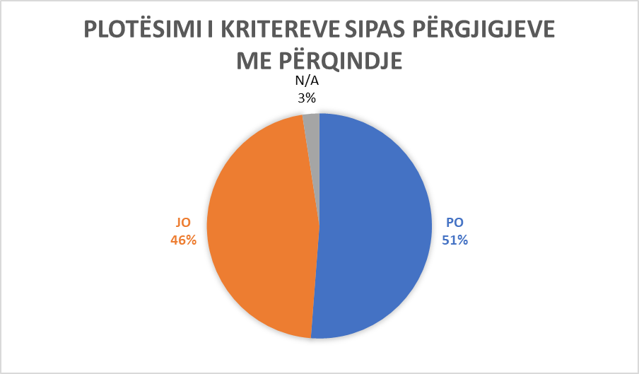

Municipality of Deçan/Dečani

Komuna e Ranillugut/ Ranilug
Ordinal number | The answer received from the municipality | Additional comments
Question No. 1  Are there tactile surfaces on public roads in your municipality and are they built according to Article 8 of Administrative Instruction No. 33/2007 for Construction Buildings Technical Terms of Accessibility to Disabled Persons (hereinafter: AI)? | YES | Local government, schools, MFMC, ambulances, kindergartens.
Question No.2  Are the ramps in public spaces and roads built according to Article 10 of the AI? | YES | (no comment)
Question No. 3  Are the stairs in the municipal public spaces built according to Article 11 of the AI? | YES | (no comment)
Question No. 4  Do the elevators in municipal public institutions fulfill the conditions according to Article 12 of the AI? | YES | Municipal administration.
Question No. 5  Do you have vertical lifting platforms and inclined folding lifting platforms in public institutions and do they meet the conditions according to Articles 13 and 14 of the AI? | NO
Question No. 6  Do the entrances to municipal public institutions meet the conditions according to Article 16 of the AI? | YES | Municipal administration, MFMC, schools, kindergartens.
Question No. 7  Do communication (communication spaces) meet conditions according to Article 17 of AI in municipal public spaces ? | YES | Municipal administration, MFMC, schools, kindergartens, municipal library.
Question No. 8  Do WC spaces in public municipal facilities meet conditions according to Article 18 of the AI? | YES | Municipal administration, schools, MFMC, ambulances.
Question No. 9  Do the bathrooms meet conditions according to Article 19 of the AI in public municipal spaces? | YES | Municipal administration.
Question No. 10  Do kitchens meet conditions according to Article 20 of the AI in municipal public spaces,? | NO
Question No. 11  Do classrooms and work spaces in public municipal facilities meet conditions according to Article 21 of the AI? | YES | Schools.
Question No. 12  Do Collective housing in the territory of the municipality meet the criteria according to Article 22 of the AI? | NO
Question No. 13  Do cafes and restaurants in the territory of the municipality meet the criteria according to Article 23 of the AI? | NO
Question No. 14  Do fitting rooms in business facilities in the territory of the municipality meet the criteria according to Article 24 of the AI? | NO
Question No. 15  Do the shower cabins in the business facilities of the municipality's territory meet the criteria according to Article 25 of the AI? | NO
Question No. 16  Do entrances to the swimming pool in the territory of the municipality meet the criteria according to Article 26 of the AI? | NO
Question No. 17  Do the seats in the tribune places in the territory of the municipality, meet the criteria according to Article 27 of the AI? | NO
Question No. 18  Does telephone, text-phone, fax and ATM in the territory of the municipality meet the criteria according to article 28 of the AI? | NO
Question No. 19  Does electrical installations in public municipal facilities meet the criteria according to article 29 of the AI? | NO
Question No. 20  Does door and windows handles in public municipal facilities meet the criteria according to Article 30 of the AI? | NO
Question No. 21  Do service points in public municipal facilities meet the criteria according to article 31 of the AI? | YES | Municipal administration.
Question No. 22  Does service counter in public municipal facilities meet the criteria according to Article 32 of the AI? | NO
Question No. 23  Do the inductive areas or the transmission circle in public municipal spaces meet the criteria according to Article 33 of the AI? | YES | Municipal administration.
Question No. 24  Do notice boards in municipal public spaces meet the criteria according to Article 34 of the AI? | YES | Municipal administration, library.
Question No. 25  Do orientation plans for movement in public municipal buildings meet the criteria according to article 35 of the AI? | NO
Question No. 26  Do bus stations and platforms in the territory of the municipality meet the criteria according to Article 37 of the AI? | NO
Question No. 27  Do parking spaces in collective spaces in the territory of the municipality meet the criteria according to Article 38 of the AI? | YES | Municipal administration, post office, MFMC, ambulances, schools, kindergartens.
Question No. 28  Do public surfaces - pedestrian paths in the territory of the municipality meet the criteria according to Article 39 of the AI? | YES | Ranillug/ Ranilug, Ropotovë/ Ropotovo.
Question No. 29  Do the traffic lights in the territory of the municipality meet the criteria according to Article 40 of the AI? | NO
Question No. 30  Do pedestrian crossings in the territory of the municipality meet the criteria according to Article 41 of the AI? | YES | Ranillug, Korminjan, Ropotovë.
Question No. 31  Do pedestrian islands in the territory of the municipality meet the criteria according to Article 42 of the AI? | YES | Ranillug, Korminjan, Ropotovë.
Question No. 32  Do the crossroads in the territory of the municipality meet the criteria according to Article 43 of the AI? | NO
Question No. 33  In the course of designing and implementation of projects, public buildings with work purpose, do you adhere to Article 44 of the AI? | YES | Municipal administration, MFMC, library, ambulances.
Question No. 34  Are the entrance gates to buildings accessible based on article 45 of the AI? | YES | Municipal administration, MFMC.
Question No. 35  Do the buildings where people with disabilities are employed meet the criteria according to Article 48 of the AI? | NO
Question No. 36  Do cafes, restaurants, etc., meet the criteria according to Article 49 of the AI? | NO
Question No. 37  Do public parking lots and public garages meet the criteria according to Article 50 of the AI? | YES | Ranillug, Ropotovë, Korminjan.
Question No. 38  During the reconstruction of buildings in your municipality, do you adhere to Article 51 of the AI? | NO
Question No. 39  Is the content of the conceptual project in your municipality based on Article 55 of the AI? | YES | Municipal administration, library, MFMC.
Question No. 40  Is the content of the main project in your municipality based on article 56 of the AI? | NO
Question No. 41  Is the content of the implementation project in your municipality based on Article 57 of the AI? | YES | Municipal administration, MFMC, library.
Additional Comments:  (In this space you can add any other information related to the questionnaire in general) |  | No comment.

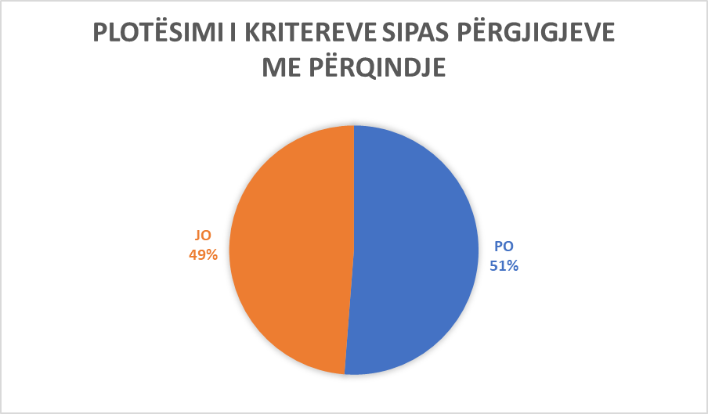

Komuna e Ranillugut/ Ranilug

Municipalitz of Novobërdë / Novo Brdo
Ordinal number | The answer received from the municipality | Additional comments
Question No. 1  Are there tactile surfaces on public roads in your municipality and are they built according to Article 8 of Administrative Instruction No. 33/2007 for Construction Buildings Technical Terms of Accessibility to Disabled Persons (hereinafter: AI)? | NO
Question No.2  Are the ramps in public spaces and roads built according to Article 10 of the AI? | NO
Question No. 3  Are the stairs in the municipal public spaces built according to Article 11 of the AI? | NO
Question No. 4  Do the elevators in municipal public institutions fulfill the conditions according to Article 12 of the AI? | NO
Question No. 5  Do you have vertical lifting platforms and inclined folding lifting platforms in public institutions and do they meet the conditions according to Articles 13 and 14 of the AI? | NO
Question No. 6  Do the entrances to municipal public institutions meet the conditions according to Article 16 of the AI? | NO
Question No. 7  Do communication (communication spaces) meet conditions according to Article 17 of AI in municipal public spaces ? | NO
Question No. 8  Do WC spaces in public municipal facilities meet conditions according to Article 18 of the AI? | NO
Question No. 9  Do the bathrooms meet conditions according to Article 19 of the AI in public municipal spaces? | NO
Question No. 10  Do kitchens meet conditions according to Article 20 of the AI in municipal public spaces,? | NO
Question No. 11  Do classrooms and work spaces in public municipal facilities meet conditions according to Article 21 of the AI? | NO
Question No. 12  Do Collective housing in the territory of the municipality meet the criteria according to Article 22 of the AI? | NO
Question No. 13  Do cafes and restaurants in the territory of the municipality meet the criteria according to Article 23 of the AI? | NO
Question No. 14  Do fitting rooms in business facilities in the territory of the municipality meet the criteria according to Article 24 of the AI? | NO
Question No. 15  Do the shower cabins in the business facilities of the municipality's territory meet the criteria according to Article 25 of the AI? | NO
Question No. 16  Do entrances to the swimming pool in the territory of the municipality meet the criteria according to Article 26 of the AI? | NO
Question No. 17  Do the seats in the tribune places in the territory of the municipality, meet the criteria according to Article 27 of the AI? | NO
Question No. 18  Does telephone, text-phone, fax and ATM in the territory of the municipality meet the criteria according to article 28 of the AI? | NO
Question No. 19  Does electrical installations in public municipal facilities meet the criteria according to article 29 of the AI? | NO
Question No. 20  Does door and windows handles in public municipal facilities meet the criteria according to Article 30 of the AI? | NO
Question No. 21  Do service points in public municipal facilities meet the criteria according to article 31 of the AI? | NO
Question No. 22  Does service counter in public municipal facilities meet the criteria according to Article 32 of the AI? | NO
Question No. 23  Do the inductive areas or the transmission circle in public municipal spaces meet the criteria according to Article 33 of the AI? | NO
Question No. 24  Do notice boards in municipal public spaces meet the criteria according to Article 34 of the AI? | NO
Question No. 25  Do orientation plans for movement in public municipal buildings meet the criteria according to article 35 of the AI? | NO
Question No. 26  Do bus stations and platforms in the territory of the municipality meet the criteria according to Article 37 of the AI? | NO
Question No. 27  Do parking spaces in collective spaces in the territory of the municipality meet the criteria according to Article 38 of the AI? | NO
Question No. 28  Do public surfaces - pedestrian paths in the territory of the municipality meet the criteria according to Article 39 of the AI? | NO
Question No. 29  Do the traffic lights in the territory of the municipality meet the criteria according to Article 40 of the AI? | NO
Question No. 30  Do pedestrian crossings in the territory of the municipality meet the criteria according to Article 41 of the AI? | NO
Question No. 31  Do pedestrian islands in the territory of the municipality meet the criteria according to Article 42 of the AI? | NO
Question No. 32  Do the crossroads in the territory of the municipality meet the criteria according to Article 43 of the AI? | NO
Question No. 33  In the course of designing and implementation of projects, public buildings with work purpose, do you adhere to Article 44 of the AI? | NO
Question No. 34  Are the entrance gates to buildings accessible based on article 45 of the AI? | NO
Question No. 35  Do the buildings where people with disabilities are employed meet the criteria according to Article 48 of the AI? | NO
Question No. 36  Do cafes, restaurants, etc., meet the criteria according to Article 49 of the AI? | NO
Question No. 37  Do public parking lots and public garages meet the criteria according to Article 50 of the AI? | NO
Question No. 38  During the reconstruction of buildings in your municipality, do you adhere to Article 51 of the AI? | NO
Question No. 39  Is the content of the conceptual project in your municipality based on Article 55 of the AI? | NO
Question No. 40  Is the content of the main project in your municipality based on article 56 of the AI? | NO
Question No. 41  Is the content of the implementation project in your municipality based on Article 57 of the AI? | NO
Additional Comments:  (In this space you can add any other information related to the questionnaire in general) |  | “At the moment we are in an institution, a building built since the 80s, which does not meet the conditions even close to this category, therefore in the future we will see the opportunity to think and act during new constructions also for this category, to have the easiest access to institutions”.

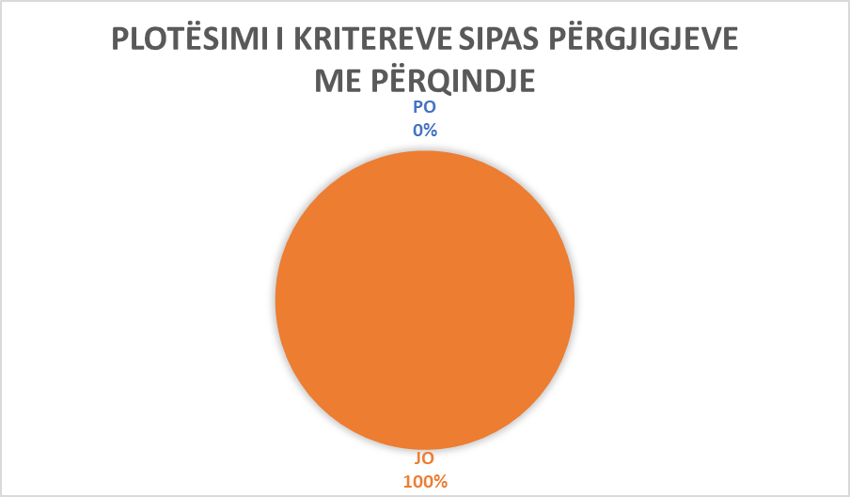

Municipality of Novobërde/ Novo Brdo

Komuna e Prishtinë/ Priština
Ordinal number | The answer received from the municipality | Additional comments
Question No. 1  Are there tactile surfaces on public roads in your municipality and are they built according to Article 8 of Administrative Instruction No. 33/2007 for Construction Buildings Technical Terms of Accessibility to Disabled Persons (hereinafter: AI)? | N/A
Question No.2  Are ramps in public spaces and roads built according to Article 10 of the AI? | N/A
Question No. 3  Are the stairs in the municipal public spaces built according to Article 11 of the AI? | N/A
Question No. 4  Do the elevators in municipal public institutions fulfill the conditions according to Article 12 of the AI? | N/A
Question No. 5  Do you have vertical lifting platforms and inclined folding lifting platforms in public institutions and do they meet the conditions according to Articles 13 and 14 of the AI? | N/A
Question No. 6  Do the entrances to municipal public institutions meet the conditions according to Article 16 of the AI? | N/A
Question No. 7  Do communication (communication spaces) meet conditions according to Article 17 of AI in municipal public spaces ? | N/A
Question No. 8  Do WC spaces in public municipal facilities meet conditions according to Article 18 of the AI? | N/A
Question No. 9  Do the bathrooms meet conditions according to Article 19 of the AI in public municipal spaces? | N/A
Question No. 10  Do kitchens meet conditions according to Article 20 of the AI in municipal public spaces,? | N/A
Question No. 11  Do classrooms and work spaces in public municipal facilities meet conditions according to Article 21 of the AI? | N/A
Question No. 12  Do Collective housing in the territory of the municipality meet the criteria according to Article 22 of the AI? | N/A
Question No. 13  Do cafes and restaurants in the territory of the municipality meet the criteria according to Article 23 of the AI? | N/A
Question No. 14  Do fitting rooms in business facilities in the territory of the municipality meet the criteria according to Article 24 of the AI? | N/A
Question No. 15  Do the shower cabins in the business facilities of the municipality's territory meet the criteria according to Article 25 of the AI? | N/A
Question No. 16  Do entrances to the swimming pool in the territory of the municipality meet the criteria according to Article 26 of the AI? | N/A
Question No. 17  Do the seats in the tribune places in the territory of the municipality, meet the criteria according to Article 27 of the AI? | N/A
Question No. 18  Does telephone, text-phone, fax and ATM in the territory of the municipality meet the criteria according to article 28 of the AI? | N/A
Question No. 19  Does electrical installations in public municipal facilities meet the criteria according to article 29 of the AI? | N/A
Question No. 20  Does door and windows handles in public municipal facilities meet the criteria according to Article 30 of the AI? | N/A
Question No. 21  Do service points in public municipal facilities meet the criteria according to article 31 of the AI? | N/A
Question No. 22  Does service counter in public municipal facilities meet the criteria according to Article 32 of the AI? | N/A
Question No. 23  Do the inductive areas or the transmission circle in public municipal spaces meet the criteria according to Article 33 of the AI? | N/A
Question No. 24  Do notice boards in municipal public spaces meet the criteria according to Article 34 of the AI? | N/A
Question No. 25  Do orientation plans for movement in public municipal buildings meet the criteria according to article 35 of the AI? | N/A
Question No. 26  Do bus stations and platforms in the territory of the municipality meet the criteria according to Article 37 of the AI? | N/A
Question No. 27  Do parking spaces in collective spaces in the territory of the municipality meet the criteria according to Article 38 of the AI? | N/A
Question No. 28  Do public surfaces - pedestrian paths in the territory of the municipality meet the criteria according to Article 39 of the AI? | N/A
Question No. 29  Do the traffic lights in the territory of the municipality meet the criteria according to Article 40 of the AI? | N/A
Question No. 30  Do pedestrian crossings in the territory of the municipality meet the criteria according to Article 41 of the AI? | N/A
Question No. 31  Do pedestrian islands in the territory of the municipality meet the criteria according to Article 42 of the AI? | N/A
Question No. 32  Do the crossroads in the territory of the municipality meet the criteria according to Article 43 of the AI? | N/A
Question No. 33  In the course of designing and implementation of projects, public buildings with work purpose, do you adhere to Article 44 of the AI? | YES | You can find all the decisions regarding construction permits for public buildings published in the link: https://prishtinaonline.com/drejtorite/urbanizmit-ndertimit/lejet-e-leshuara where for these decisions with requests for access to public documents, you have the opprtunity to look at approved projects.
Question No. 34  Are the entrance gates to buildings accessible based on article 45 of the AI? | N/A
Question No. 35  Do the buildings where people with disabilities are employed meet the criteria according to Article 48 of the AI? | N/A
Question No. 36  Do cafes, restaurants, etc., meet the criteria according to Article 49 of the AI? | N/A
Question No. 37  Do public parking lots and public garages meet the criteria according to Article 50 of the AI? | N/A
Question No. 38  During the reconstruction of buildings in your municipality, do you adhere to Article 51 of the AI? | N/A
Question No. 39  Is the content of the conceptual project in your municipality based on Article 55 of the AI? | YES | You can find the decisions on the construction permit according to the conceptual/main project published in the link described in point 33.
Question No. 40  Is the content of the main project in your municipality based on article 56 of the AI? | YES | You can find the decisions on the construction permit published in the link described in the point 33.
Question No. 41  Is the content of the implementation project in your municipality based on Article 57 of the AI? | N/A
Additional Comments:

(In this space you can add any other information related to the questionnaire in general)

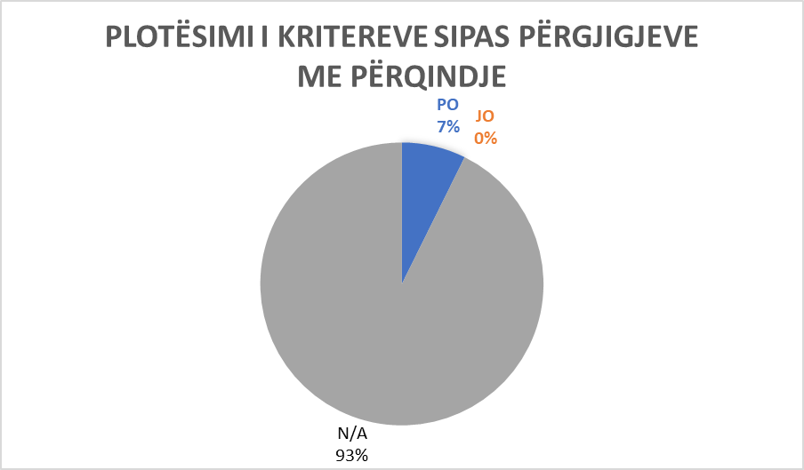

Municipality of Prishtinë/ Priština

Municipality of Kaçanikut/ Kačanik
Ordinal number | The answer received from the municipality | Additional comments
Question No. 1  Are there tactile surfaces on public roads in your municipality and are they built according to Article 8 of Administrative Instruction No. 33/2007 for Construction Buildings Technical Terms of Accessibility to Disabled Persons (hereinafter: AI)? | YES | In the construction project of the city square, the construction of the tact surface is foreseen. The project is in the final stage of implementation.
Question No.2  Are the ramps in public spaces and roads built according to Article 10 of the AI? | YES | Locations: Municipal building, schools, "Ismail Raka" boulevard. Some of them are not built according to Article 10.
Question No. 3  Are the stairs in the municipal public spaces built according to Article 11 of the AI? | YES | The municipal facility, school facilities, the house of culture "Xheladin Kurtaj”.
Question No. 4  Do the elevators in municipal public institutions fulfill the conditions according to Article 12 of the AI? | NO
Question No. 5  Do you have vertical lifting platforms and inclined folding lifting platforms in public institutions and do they meet the conditions according to Articles 13 and 14 of the AI? | NO
Question No. 6  Do the entrances to municipal public institutions meet the conditions according to Article 16 of the AI? | YES | All school facilities.
Question No. 7  Do communication (communication spaces) meet conditions according to Article 17 of AI in municipal public spaces ? | YES | School facilities, the house of culture, the municipal facility.
Question No. 8  Do WC spaces in public municipal facilities meet conditions according to Article 18 of the AI? | NO
Question No. 9  Do the bathrooms meet conditions according to Article 19 of the AI in public municipal spaces? | NO
Question No. 10  Do kitchens meet conditions according to Article 20 of the AI in municipal public spaces,? | YES | The daycare center of the city 'Agimi'.
Question No. 11  Do classrooms and work spaces in public municipal facilities meet conditions according to Article 21 of the AI? | YES | Municipal facility, school, QEAP "Agimi", gymnasium, country offices.
Question No. 12  Do Collective housing in the territory of the municipality meet the criteria according to Article 22 of the AI? | YES | All residential facilities.
Question No. 13  Do cafes and restaurants in the territory of the municipality meet the criteria according to Article 23 of the AI? | NO
Question No. 14  Do fitting rooms in business facilities in the territory of the municipality meet the criteria according to Article 24 of the AI? | NO
Question No. 15  Do the shower cabins in the business facilities of the municipality's territory meet the criteria according to Article 25 of the AI? | NO
Question No. 16  Do entrances to the swimming pool in the territory of the municipality meet the criteria according to Article 26 of the AI? | NO
Question No. 17  Do the seats in the tribune places in the territory of the municipality, meet the criteria according to Article 27 of the AI? | YES | City gym.
Question No. 18  Does telephone, textphone, fax and ATM in the territory of the municipality meet the criteria according to article 28 of the AI? | YES | NLB, Raiffaisen Bank, Economic Bank.
Question No. 19  Does electrical installations in public municipal facilities meet the criteria according to article 29 of the AI? | YES | All schools, municipal building .
Question No. 20  Does door and windows handles in public municipal facilities meet the criteria according to Article 30 of the AI? | YES | All buildings.
Question No. 21  Do service points in public municipal facilities meet the criteria according to article 31 of the AI? | NO
Question No. 22  Does service counter in public municipal facilities meet the criteria according to Article 32 of the AI? | NO
Question No. 23  Do the inductive areas or the transmission circle in public municipal spaces meet the criteria according to Article 33 of the AI? | NO
Question No. 24  Do notice boards in municipal public spaces meet the criteria according to Article 34 of the AI? | YES | At the municipal building .
Question No. 25  Do orientation plans for movement in public municipal buildings meet the criteria according to article 35 of the AI? | NO
Question No. 26  Do bus stations and platforms in the territory of the municipality meet the criteria according to Article 37 of the AI? | NO
Question No. 27  Do parking spaces in collective spaces in the territory of the municipality meet the criteria according to Article 38 of the AI? | NO
Question No. 28  Do public surfaces - pedestrian paths in the territory of the municipality meet the criteria according to Article 39 of the AI? | YES | "Ismail Raka" boulevard”
Question No. 29  Do the traffic lights in the territory of the municipality meet the criteria according to Article 40 of the AI? | NO
Question No. 30  Do pedestrian crossings in the territory of the municipality meet the criteria according to Article 41 of the AI? | YES | "Ismail Raka" Boulevard, Str. "V. Çaka", Str. Qamil Ilazi”.
Question No. 31  Do pedestrian islands in the territory of the municipality meet the criteria according to Article 42 of the AI? | NO
Question No. 32  Do the crossroads in the territory of the municipality meet the criteria according to Article 43 of the AI? | NO
Question No. 33  In the course of designing and implementation of projects, public buildings with work purpose, do you adhere to Article 44 of the AI? | NO
Question No. 34  Are the entrance gates to buildings accessible based on article 45 of the AI? | YES | Some of them: MFMC building.
Question No. 35  Do the buildings where people with disabilities are employed meet the criteria according to Article 48 of the AI? | NO
Question No. 36  Do cafes, restaurants, etc., meet the criteria according to Article 49 of the AI? | NO
Question No. 37  Do public parking lots and public garages meet the criteria according to Article 50 of the AI? | YES | Boulevard “Ismail Raka”.
Question No. 38  During the reconstruction of buildings in your municipality, do you adhere to Article 51 of the AI? | YES | Renovations of school buildings, renovation of the municipal building requires the fulfillment of all conditions for access.
Question No. 39  Is the content of the conceptual project in your municipality based on Article 55 of the AI? | YES | All objects that are built and that have a construction permit.
Question No. 40  Is the content of the main project in your municipality based on article 56 of the AI? | YES | In the entire municipal area.
Question No. 41  Is the content of the implementation project in your municipality based on Article 57 of the AI? | YES | In the entire municipal area.
Additional Comments:  (In this space you can add any other information related to the questionnaire in general) |  | “Municipality of Kaçanik is continuously trying to realize the projects based on the AI”.

Municipality of Kaçanik/ Kačanik

Municipality of Klinë/ Klina
Ordinal number | The answer received from the municipality | Additional comments
Question No. 1  Are there tactile surfaces on public roads in your municipality and are they built according to Article 8 of Administrative Instruction No. 33/2007 for Construction Buildings Technical Terms of Accessibility to Disabled Persons (hereinafter: AI)? | NO
Question No.2  Are the ramps in public spaces and roads built according to Article 10 of the AI? | YES | At the house of culture .
Question No. 3  Are the stairs in the municipal public spaces built according to Article 11 of the AI? | NO
Question No. 4  Do the elevators in municipal public institutions fulfill the conditions according to Article 12 of the AI? | NO
Question No. 5  Do you have vertical lifting platforms and inclined folding lifting platforms in public institutions and do they meet the conditions according to Articles 13 and 14 of the AI? | NO
Question No. 6  Do the entrances to municipal public institutions meet the conditions according to Article 16 of the AI? | NO
Question No. 7  Do communication (communication spaces) meet conditions according to Article 17 of AI in municipal public spaces ? | NO
Question No. 8  Do WC spaces in public municipal facilities meet conditions according to Article 18 of the AI? | NO
Question No. 9  Do the bathrooms meet conditions according to Article 19 of the AI in public municipal spaces? | NO
Question No. 10  Do kitchens meet conditions according to Article 20 of the AI in municipal public spaces,? | NO
Question No. 11  Do classrooms and work spaces in public municipal facilities meet conditions according to Article 21 of the AI? | YES | Municipal Assembly - Klinë police station, "Fehmi Agani" professional technical high school, health center “Nënë Terezë”, the house of culture, primary school "Ismet Raci”.
Question No. 12  Do Collective housing in the territory of the municipality meet the criteria according to Article 22 of the AI? | NO
Question No. 13  Do cafes and restaurants in the territory of the municipality meet the criteria according to Article 23 of the AI? | NO
Question No. 14  Do fitting rooms in business facilities in the territory of the municipality meet the criteria according to Article 24 of the AI? | NO
Question No. 15  Do the shower cabins in the business facilities of the municipality's territory meet the criteria according to Article 25 of the AI? | NO
Question No. 16  Do entrances to the swimming pool in the territory of the municipality meet the criteria according to Article 26 of the AI? | YES | Euro Park in Zllakuqan.
Question No. 17  Do the seats in the tribune places in the territory of the municipality, meet the criteria according to Article 27 of the AI? | YES | Sports center "Adem Jashari”.
Question No. 18  Does telephone, textphone, fax and ATM in the territory of the municipality meet the criteria according to article 28 of the AI? | YES | PTK-ja, ATM – Raifaissen Bank, NLB.
Question No. 19  Does electrical installations in public municipal facilities meet the criteria according to article 29 of the AI? | YES | Klinë municipality - police station, schools.
Question No. 20  Does door and windows handles in public municipal facilities meet the criteria according to Article 30 of the AI? | YES | Klinë municipality - police station, schools
Question No. 21  Do service points in public municipal facilities meet the criteria according to article 31 of the AI? | YES | Klinë municipality, health center, police station.
Question No. 22  Does service counter in public municipal facilities meet the criteria according to Article 32 of the AI? | NO
Question No. 23  Do the inductive areas or the transmission circle in public municipal spaces meet the criteria according to Article 33 of the AI? | NO
Question No. 24  Do notice boards in municipal public spaces meet the criteria according to Article 34 of the AI? | YES | Squere “Mujë Krasniqi”, Str. “Abedin Rexha”, Str. “Dëshmorët e Kombit”, Str. “Sadik Rama”.
Question No. 25  Do orientation plans for movement in public municipal buildings meet the criteria according to article 35 of the AI? | NO
Question No. 26  Do bus stations and platforms in the territory of the municipality meet the criteria according to Article 37 of the AI? | NO
Question No. 27  Do parking spaces in collective spaces in the territory of the municipality meet the criteria according to Article 38 of the AI? | YES | Str. “Abedin Rexha”, Str. “Dëshmorët e Kombit”, Str. “Ymër Berisha”, Squere “Faruk Elezi”, Police Station
Question No. 28  Do public surfaces - pedestrian paths in the territory of the municipality meet the criteria according to Article 39 of the AI? | YES | City square, Str. “Sadik Rama”.
Question No. 29  Do the traffic lights in the territory of the municipality meet the criteria according to Article 40 of the AI? | NO
Question No. 30  Do pedestrian crossings in the territory of the municipality meet the criteria according to Article 41 of the AI? | YES | City square.
Question No. 31  Do pedestrian islands in the territory of the municipality meet the criteria according to Article 42 of the AI? | NO
Question No. 32  Do the crossroads in the territory of the municipality meet the criteria according to Article 43 of the AI? | NO
Question No. 33  In the course of designing and implementation of projects, public buildings with work purpose, do you adhere to Article 44 of the AI? | NO
Question No. 34  Are the entrance gates to buildings accessible based on article 45 of the AI? | YES | Municipality of Klinë, MFMC.
Question No. 35  Do the buildings where people with disabilities are employed meet the criteria according to Article 48 of the AI? | YES | Police Statuion, MFMC.
Question No. 36  Do cafes, restaurants, etc., meet the criteria according to Article 49 of the AI? | NO
Question No. 37  Do public parking lots and public garages meet the criteria according to Article 50 of the AI? | YES | Dëshmorët e Kombit (1x), Sheshi Mujë Krasniqi (2x), Str. Abedin Rexha (2x), Str. Ymër Berisha (2x), Str. Skender Rexhepi (2x).
Question No. 38  During the reconstruction of buildings in your municipality, do you adhere to Article 51 of the AI? | YES | Schools, CSW facilities, municipalities.
Question No. 39  Is the content of the conceptual project in your municipality based on Article 55 of the AI? | N/A
Question No. 40  Is the content of the main project in your municipality based on article 56 of the AI? | NO
Question No. 41  Is the content of the implementation project in your municipality based on Article 57 of the AI? | YES | The court, schools, Municipality of Klinë, sports centers.
Additional Comments:  (In this space you can add any other information related to the questionnaire in general) |  | “As far as it is known to us and we are aware of, within the territory of our municipality (Klina), we have tried to be accurate and all the information provided is grounded on facts”.

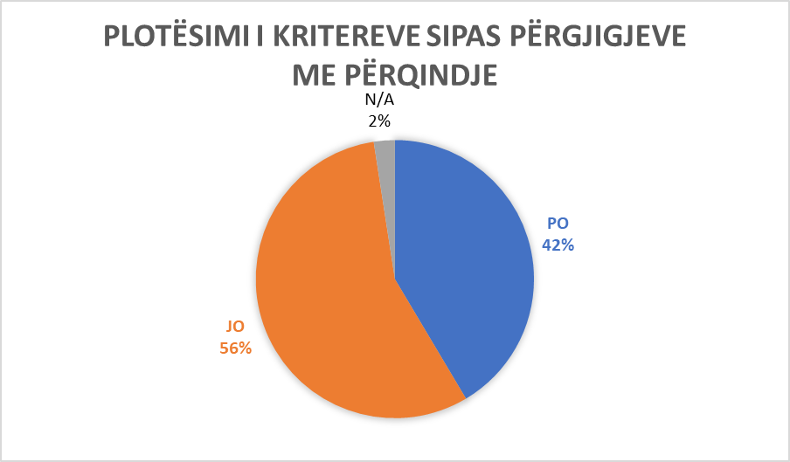

Municipality of Klina

Municipality of Fushë Kosovë/ Kosovo Polje
Ordinal number | The answer received from the municipality | Additional comments
Question No. 1  Are there tactile surfaces on public roads in your municipality and are they built according to Article 8 of Administrative Instruction No. 33/2007 for Construction Buildings Technical Terms of Accessibility to Disabled Persons (hereinafter: AI)? | NO
Question No.2  Are ramps in public spaces and roads built according to Article 10 of the AI? | NO | Partly, the municipality facility, the entrance 2.
Question No. 3  Are the stairs in the municipal public spaces built according to Article 11 of the AI? | YES | External dim. 15/36 –satisfies while internal criteria have dim: 18/33
Question No. 4  Do the elevators in municipal public institutions fulfill the conditions according to Article 12 of the AI? | YES | There is an elevator in the municipal building, which is currently not in operation due to the construction of the second floor (reconstruction).
Question No. 5  Do you have vertical lifting platforms and inclined folding lifting platforms in public institutions and do they meet the conditions according to Articles 13 and 14 of the AI? | NO
Question No. 6  Do the entrances to municipal public institutions meet the conditions according to Article 16 of the AI? | YES | The entrance door itself to the municipal building, to schools and MFMC.
Question No. 7  Do communication (communication spaces) meet conditions according to Article 17 of AI in municipal public spaces ? | NO | Partly in the municipality facility, school and MFMC.
Question No. 8  Do WC spaces in public municipal facilities meet conditions according to Article 18 of the AI? | YES | In the municipality building and in the Mihal Grameno school, we are renovating.
Question No. 9  Do the bathrooms meet conditions according to Article 19 of the AI in public municipal spaces? | NO
Question No. 10  Do kitchens meet conditions according to Article 20 of the AI in municipal public spaces,? | NO
Question No. 11  Do classrooms and work spaces in public municipal facilities meet conditions according to Article 21 of the AI? | NO | Partially, not all criteria according to the Instruction.
Question No. 12  Do Collective housing in the territory of the municipality meet the criteria according to Article 22 of the AI? | NO | Partially, access to the elevator, the entrance door, the width of the corridor.
Question No. 13  Do cafes and restaurants in the territory of the municipality meet the criteria according to Article 23 of the AI? | NO
Question No. 14  Do fitting rooms in business facilities in the territory of the municipality meet the criteria according to Article 24 of the AI? | NO
Question No. 15  Do the shower cabins in the business facilities of the municipality's territory meet the criteria according to Article 25 of the AI? | NO
Question No. 16  Do entrances to the swimming pool in the territory of the municipality meet the criteria according to Article 26 of the AI? | NO
Question No. 17  Do the seats in the tribune places in the territory of the municipality, meet the criteria according to Article 27 of the AI? | NO
Question No. 18  Does telephone, textphone, fax and ATM in the territory of the municipality meet the criteria according to article 28 of the AI? | NO
Question No. 19  Does electrical installations in public municipal facilities meet the criteria according to article 29 of the AI? | YES | In the municipal building, the school, MFMC, CSW.
Question No. 20  Does door and windows handles in public municipal facilities meet the criteria according to Article 30 of the AI? | NO
Question No. 21  Do service points in public municipal facilities meet the criteria according to article 31 of the AI? | NO
Question No. 22  Does service counter in public municipal facilities meet the criteria according to Article 32 of the AI? | NO
Question No. 23  Do the inductive areas or the transmission circle in public municipal spaces meet the criteria according to Article 33 of the AI? | NO
Question No. 24  Do notice boards in municipal public spaces meet the criteria according to Article 34 of the AI? | NO
Question No. 25  Do orientation plans for movement in public municipal buildings meet the criteria according to article 35 of the AI? | NO
Question No. 26  Do bus stations and platforms in the territory of the municipality meet the criteria according to Article 37 of the AI? | NO | Partially.
Question No. 27  Do parking spaces in collective spaces in the territory of the municipality meet the criteria according to Article 38 of the AI? | YES | At the railway station and taxi parking place- roundabout.
Question No. 28  Do public surfaces - pedestrian paths in the territory of the municipality meet the criteria according to Article 39 of the AI? | NO
Question No. 29  Do the traffic lights in the territory of the municipality meet the criteria according to Article 40 of the AI? | NO
Question No. 30  Do pedestrian crossings in the territory of the municipality meet the criteria according to Article 41 of the AI? | NO
Question No. 31  Do pedestrian islands in the territory of the municipality meet the criteria according to Article 42 of the AI? | NO
Question No. 32  Do the crossroads in the territory of the municipality meet the criteria according to Article 43 of the AI? | NO
Question No. 33  In the course of designing and implementation of projects, public buildings with work purpose, do you adhere to Article 44 of the AI? | NO | Partially: Access to the elevator (level ~ O), and the width of the corridors 150cm (municipality, school, MFMC).
Question No. 34  Are the entrance gates to buildings accessible based on article 45 of the AI? | YES | Municipality building, MFMC.
Question No. 35  Do the buildings where people with disabilities are employed meet the criteria according to Article 48 of the AI? | YES | Municipality building.
Question No. 36  Do cafes, restaurants, etc., meet the criteria according to Article 49 of the AI? | NO | The municipality has only small businesses.
Question No. 37  Do public parking lots and public garages meet the criteria according to Article 50 of the AI? | YES | At the roundabout – pablic parking.
Question No. 38  During the reconstruction of buildings in your municipality, do you adhere to Article 51 of the AI? | YES | Yes, in the facility of the municipality, the Mihail Grameno school, MFMC.
Question No. 39  Is the content of the conceptual project in your municipality based on Article 55 of the AI? | NO
Question No. 40  Is the content of the main project in your municipality based on article 56 of the AI? | NO
Question No. 41  Is the content of the implementation project in your municipality based on Article 57 of the AI? | NO
Additional Comments:  (In this space you can add any other information related to the questionnaire in general) |  | No comment.

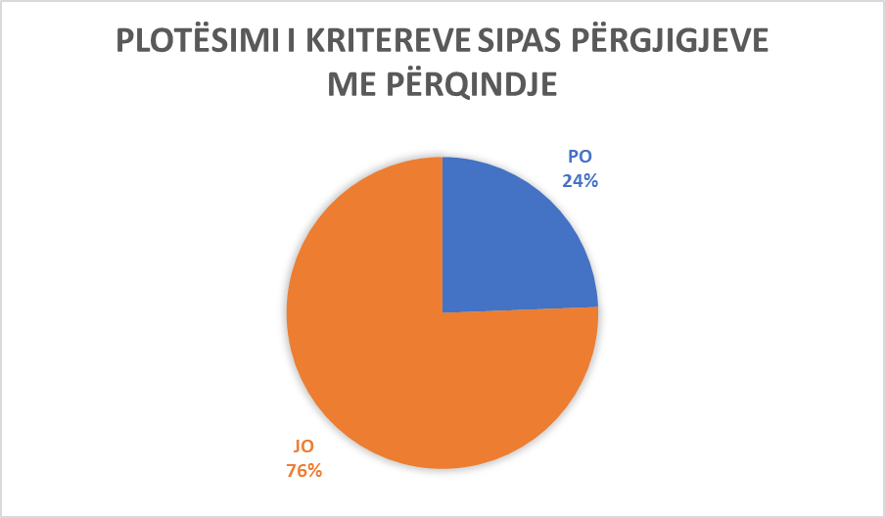

Municipality of Fushë Kosovë/ Kosovo Polje

Municipality of Obiliq/ Obilić
Ordinal number | The answer received from the municipality | Additional comments
Question No. 1  Are there tactile surfaces on public roads in your municipality and are they built according to Article 8 of Administrative Instruction No. 33/2007 for Construction Buildings Technical Terms of Accessibility to Disabled Persons (hereinafter: AI)? | NO
Question No.2  Are the ramps in public spaces and roads built according to Article 10 of the AI? | NO
Question No. 3  Are the stairs in the municipal public spaces built according to Article 11 of the AI? | PO | In all communal spaces, stairs are built according to Article 11 of the AI.
Question No. 4  Do the elevators in municipal public institutions fulfill the conditions according to Article 12 of the AI? | YES | In the municipal facility.
Question No. 5  Do you have vertical lifting platforms and inclined folding lifting platforms in public institutions and do they meet the conditions according to Articles 13 and 14 of the AI? | NO
Question No. 6  Do the entrances to municipal public institutions meet the conditions according to Article 16 of the AI? | YES | Yes, all entrance spaces in municipal public institutions meet the conditions according to Article 16 of the AI.
Question No. 7  Do communication (communication spaces) meet conditions according to Article 17 of AI in municipal public spaces ? | NO
Question No. 8  Do WC spaces in public municipal facilities meet conditions according to Article 18 of the AI? | NO
Question No. 9  Do the bathrooms meet conditions according to Article 19 of the AI in public municipal spaces? | NO
Question No. 10  Do kitchens meet conditions according to Article 20 of the AI in municipal public spaces,? | NO
Question No. 11  Do classrooms and work spaces in public municipal facilities meet conditions according to Article 21 of the AI? | NO
Question No. 12  Do Collective housing in the territory of the municipality meet the criteria according to Article 22 of the AI? | NO
Question No. 13  Do cafes and restaurants in the territory of the municipality meet the criteria according to Article 23 of the AI? | NO
Question No. 14  Do fitting rooms in business facilities in the territory of the municipality meet the criteria according to Article 24 of the AI? | NO
Question No. 15  Do the shower cabins in the business facilities of the municipality's territory meet the criteria according to Article 25 of the AI? | NO
Question No. 16  Do entrances to the swimming pool in the territory of the municipality meet the criteria according to Article 26 of the AI? | YES | Yes, the Swiss Wellness Park swimming pool, in Milloshevë.
Question No. 17  Do the seats in the tribune places in the territory of the municipality, meet the criteria according to Article 27 of the AI? | YES | The tribune at Adem Jashari sports center meets the criteria according to Article 27 of the AI.
Question No. 18  Does telephone, textphone, fax and ATM in the territory of the municipality meet the criteria according to article 28 of the AI? | NO
Question No. 19  Does electrical installations in public municipal facilities meet the criteria according to article 29 of the AI? | NO
Question No. 20  Does door and windows handles in public municipal facilities meet the criteria according to Article 30 of the AI? | NO
Question No. 21  Do service points in public municipal facilities meet the criteria according to article 31 of the AI? | NO
Question No. 22  Does service counter in public municipal facilities meet the criteria according to Article 32 of the AI? | NO
Question No. 23  Do the inductive areas or the transmission circle in public municipal spaces meet the criteria according to Article 33 of the AI? | NO
Question No. 24  Do notice boards in municipal public spaces meet the criteria according to Article 34 of the AI? | YES | Yes, in the municipal building and in the city squares.
Question No. 25  Do orientation plans for movement in public municipal buildings meet the criteria according to article 35 of the AI? | YES | In the municipality facility,
Question No. 26  Do bus stations and platforms in the territory of the municipality meet the criteria according to Article 37 of the AI? | NO
Question No. 27  Do parking spaces in collective spaces in the territory of the municipality meet the criteria according to Article 38 of the AI? | YES | In all municipal parking lots.
Question No. 28  Do public surfaces - pedestrian paths in the territory of the municipality meet the criteria according to Article 39 of the AI? | NO
Question No. 29  Do the traffic lights in the territory of the municipality meet the criteria according to Article 40 of the AI? | NO
Question No. 30  Do pedestrian crossings in the territory of the municipality meet the criteria according to Article 41 of the AI? | YES | Crosswalks in the city center meet the criteria.
Question No. 31  Do pedestrian islands in the territory of the municipality meet the criteria according to Article 42 of the AI? | NO
Question No. 32  Do the crossroads in the territory of the municipality meet the criteria according to Article 43 of the AI? | NO
Question No. 33  In the course of designing and implementation of projects, public buildings with work purpose, do you adhere to Article 44 of the AI? | YES | (no comment)
Question No. 34  Are the entrance gates to buildings accessible based on article 45 of the AI? | YES | Entrance gates to municipal facilities are accessible, MFMC, Sports Gym, House of Culture, City Library.
Question No. 35  Do the buildings where people with disabilities are employed meet the criteria according to Article 48 of the AI? | NO
Question No. 36  Do cafes, restaurants, etc., meet the criteria according to Article 49 of the AI? | NO
Question No. 37  Do public parking lots and public garages meet the criteria according to Article 50 of the AI? | YES | Yes, parking lots in the municipal facility, city parking lots.
Question No. 38  During the reconstruction of buildings in your municipality, do you adhere to Article 51 of the AI? | YES | Yes, according to applicable laws.
Question No. 39  Is the content of the conceptual project in your municipality based on Article 55 of the AI? | YES | (no comment)
Question No. 40  Is the content of the main project in your municipality based on article 56 of the AI? | YES | (no comment)
Question No. 41  Is the content of the implementation project in your municipality based on Article 57 of the AI? | YES | (no comment)
Additional Comments:

(In this space you can add any other information related to the questionnaire in general)

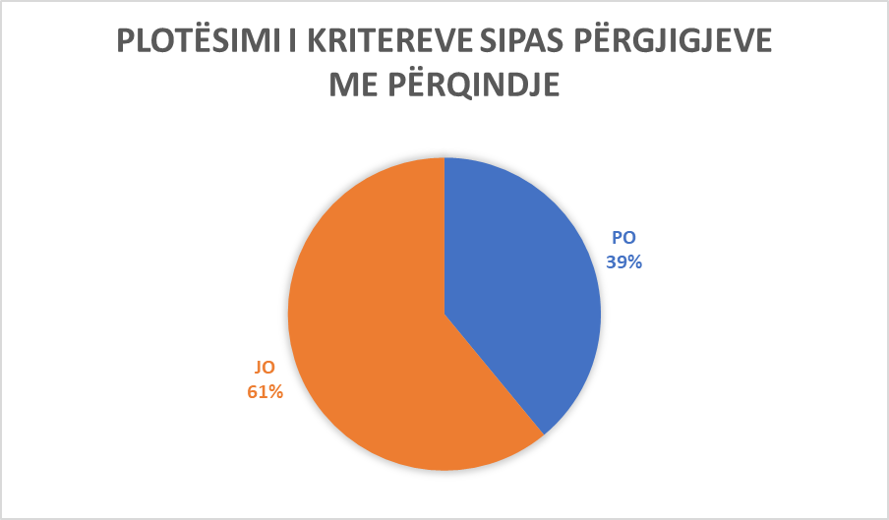

Municipality of Obiliq/Obilić

Municipality of Ferizaj/Urosevac
Ordinal number | The answer received from the municipality | Additional comments
Question No. 1  Are there tactile surfaces on public roads in your municipality and are they built according to Article 8 of Administrative Instruction No. 33/2007 for Construction Buildings Technical Terms of Accessibility to Disabled Persons (hereinafter: AI)? | YES | The Municipality of Ferizaj, through the Directorate of Public Services and the Directorate of Infrastructure, has implemented a series of projects with the aim of facilitating the movement of persons with disabilities. As for the tact surfaces on public roads, the Municipality of Ferizaj has positioned these spaces in Dëshmorët e Kombit square and we are in the planning stage for other public roads as well..
Question No.2  Are the ramps in public spaces and roads built according to Article 10 of the AI? | YES | In the framework of the implementation of various infrastructural works, the Municipality of Ferizaj has jointly implemented the project for the placement of ramps in public spaces and roads, specifically in the infrastructure project Bashkimi i Cittiti - the underpass for cars and pedestrians, it has also implemented the project for the arrangement of the public toilet at Parku Liria. So, in general, we can conclude that in all infrastructure projects, on public roads, various public institutions, but also in public spaces where there are differences, there are also ramps with accompanying infrastructure..
Question No. 3  Are the stairs in the municipal public spaces built according to Article 11 of the AI? | NO | In the projects where the Municipality has invested, the stairs have been built according to the standards provided in the legislation in force, the technical regulation, except for the tactical areas that are missing in some of these projects.
Question No. 4  Do the elevators in municipal public institutions fulfill the conditions according to Article 12 of the AI? | NO | Elevators are located in some of the public institutions, but of course it remains in our plans that they be adapted and adjusted in such a way as to enable access according to the provisions of sub-legal acts that regulate this field.
Question No. 5  Do you have vertical lifting platforms and inclined folding lifting platforms in public institutions and do they meet the conditions according to Articles 13 and 14 of the AI? | NO | The answer to question 4 is applicable here where the Municipality with its specialized institutions in this field is in the phase of planning and implementing projects according to such standards required by by-laws.
Question No. 6  Do the entrances to municipal public institutions meet the conditions according to Article 16 of the AI? | YES | In most public institutions, the conditions for access to its entrance spaces are met, but as an investment and planning, it is continuous on the part of the Municipality of Ferizaj. As for example in school facilities, Court, Prosecutor's Office, Theater, Library, etc.
Question No. 7  Do communication (communication spaces) meet conditions according to Article 17 of AI in municipal public spaces ? | NO | Progress has been made in this direction, in the planning and implementation of infrastructure projects on our part, but as such, they remain within our short-term investment plans..
Question No. 8  Do WC spaces in public municipal facilities meet conditions according to Article 18 of the AI? | YES | Partially, in most public institutions, these criteria are met, but as an investment and planning, it is continuous on the part of the Municipality of Ferizaj. For example, these criteria are met in some of the school facilities, the Court, the Prosecutor's Office, etc.
Question No. 9  Do the bathrooms meet conditions according to Article 19 of the AI in public municipal spaces? | NO | In some of the institutions, these criteria are implemented, but in most of them, due to technical specifications, they could not be implemented..
Question No. 10  Do kitchens meet conditions according to Article 20 of the AI in municipal public spaces,? | NO | In some of the institutions, these criteria are implemented, but in most of them, they could not be implemented..
Question No. 11  Do classrooms and work spaces in public municipal facilities meet conditions according to Article 21 of the AI? | NO | These criteria are partially applied in some of the municipal institutions or subordinate to the Municipality.
Question No. 12  Do Collective housing in the territory of the municipality meet the criteria according to Article 22 of the AI? | YES | In most of the collective housing facilities, these criteria are applied, but exceptionally in cases of the earliest constructions, due to technical specifications, these criteria cannot be applied.
Question No. 13  Do cafes and restaurants in the territory of the municipality meet the criteria according to Article 23 of the AI? | NO | These criteria are not fully met in cafes and restaurants in the territory of the Municipality of Ferizaj.
Question No. 14  Do fitting rooms in business facilities in the territory of the municipality meet the criteria according to Article 24 of the AI? | NO | These criteria are not fully met in business facilities in the territory of the Municipality of Ferizaj.
Question No. 15  Do the shower cabins in the business facilities of the municipality's territory meet the criteria according to Article 25 of the AI? | NO | These criteria are not fully met in business facilities in the territory of the Municipality of Ferizaj.
Question No. 16  Do entrances to the swimming pool in the territory of the municipality meet the criteria according to Article 26 of the AI? | NO | These criteria are not fully met at the entrances to the swimming pools in the territory of the Municipality of Ferizaj.
Question No. 17  Do the seats in the tribune places in the territory of the municipality, meet the criteria according to Article 27 of the AI? | NO | These criteria are not fully met in places with stands in the territory of the Municipality of Ferizaj.
Question No. 18  Does telephone, textphone, fax and ATM in the territory of the municipality meet the criteria according to article 28 of the AI? | YES | In most of these services offered by institutions, these criteria are met.
Question No. 19  Does electrical installations in public municipal facilities meet the criteria according to article 29 of the AI? | YES | Yes, in almost all municipal public institutions, these criteria are applied.
Question No. 20  Does door and windows handles in public municipal facilities meet the criteria according to Article 30 of the AI? | NO | In some institutions, this criterion is applied, but it remains within the framework of our continuous investments for the improvement of the infrastructure necessary for the access of persons with disabilities.
Question No. 21  Do service points in public municipal facilities meet the criteria according to article 31 of the AI? | YES | Some of these counters apply these criteria.
Question No. 22  Does service counter in public municipal facilities meet the criteria according to Article 32 of the AI? | NO | These criteria are not fully met in municipal facilities.
Question No. 23  Do the inductive areas or the transmission circle in public municipal spaces meet the criteria according to Article 33 of the AI? | NO | These criteria are not fully met in municipal facilities.
Question No. 24  Do notice boards in municipal public spaces meet the criteria according to Article 34 of the AI? | YES | Yes, they fully meet the necessary accessibility and visibility criteria.
Question No. 25  Do orientation plans for movement in public municipal buildings meet the criteria according to article 35 of the AI? | NO | In those buildings where these plans are implemented, these criteria are partially implemented, with the exception of the Braille alphabet.
Question No. 26  Do bus stations and platforms in the territory of the municipality meet the criteria according to Article 37 of the AI? | YES | Yes, these criteria are applied in the spaces dedicated for these purposes, such as the Bus Station, str. Ahmet Kaçiku, Ramadan Rexhepi, Brahim Ademi, Brigade 161, as well as in some villages, the construction of stops and cabins for travelers has begun, where the regulation of access for people with disabilities, etc..
Question No. 27  Do parking spaces in collective spaces in the territory of the municipality meet the criteria according to Article 38 of the AI? | YES | Yes, partially, the parking lots in the spaces of institutions and public roads, such as Police Station, Court, Prosecutor's Office, Banks, Str. Dëshmorët e Kombit, KEDS-it, etc.
Question No. 28  Do public surfaces - pedestrian paths in the territory of the municipality meet the criteria according to Article 39 of the AI? | NO | These criteria are not fully met in some public areas.
Question No. 29  Do the traffic lights in the territory of the municipality meet the criteria according to Article 40 of the AI? | NO | Currently, Ferizaj Municipality does not have functional traffic lights.
Question No. 30  Do pedestrian crossings in the territory of the municipality meet the criteria according to Article 41 of the AI? | NO | Yes, partly but there are no tactile areas, as in the city streets, practically in front of the pedestrian crossings, the slopes are arranged for access for the disabled.
Question No. 31  Do pedestrian islands in the territory of the municipality meet the criteria according to Article 42 of the AI? | NO | These criteria are not fully met.
Question No. 32  Do the crossroads in the territory of the municipality meet the criteria according to Article 43 of the AI? | NO | At the crossroads, the slopes are fixed, but the tactile fields are missing.
Question No. 33  In the course of designing and implementation of projects, public buildings with work purpose, do you adhere to Article 44 of the AI? | YES | Yes, as for example in the construction project of MFMC, FMC, Bus Station and in buildings for collective housing.
Question No. 34  Are the entrance gates to buildings accessible based on article 45 of the AI? | YES | Yes, they are accessible in almost all public institutions.
Question No. 35  Do the buildings where people with disabilities are employed meet the criteria according to Article 48 of the AI? | YES | Yes, as for example in the Municipality facility.
Question No. 36  Do cafes, restaurants, etc., meet the criteria according to Article 49 of the AI? | NO | These criteria are not fully met.
Question No. 37  Do public parking lots and public garages meet the criteria according to Article 50 of the AI? | YES | Yes, they are filled, for example, in the parking lots of public facilities, public roads, business facilities, as well as at the underpass.
Question No. 38  During the reconstruction of buildings in your municipality, do you adhere to Article 51 of the AI? | YES | Yes, it is adhered to and the existing facilities have access for people with disabilities.
Question No. 39  Is the content of the conceptual project in your municipality based on Article 55 of the AI? | YES | Yes, conceptual designers for multi-residential buildings adhere to the conceptual project and it is based on these criteria.
Question No. 40  Is the content of the main project in your municipality based on article 56 of the AI? | YES | Yes, in the main projects in multi-residential facilities all adhere to these criteria and can be adjusted for this category, in cases where they are not applicable.
Question No. 41  Is the content of the implementation project in your municipality based on Article 57 of the AI? | YES | Yes, to all licensed buildings.
Additional Comments:  (In this space you can add any other information related to the questionnaire in general) |  | No additional comment .
(The Municipality of Ferizaj did not abide by the required form of the questionnaire. The answers are interpreted according to the comments made by this municipality.)
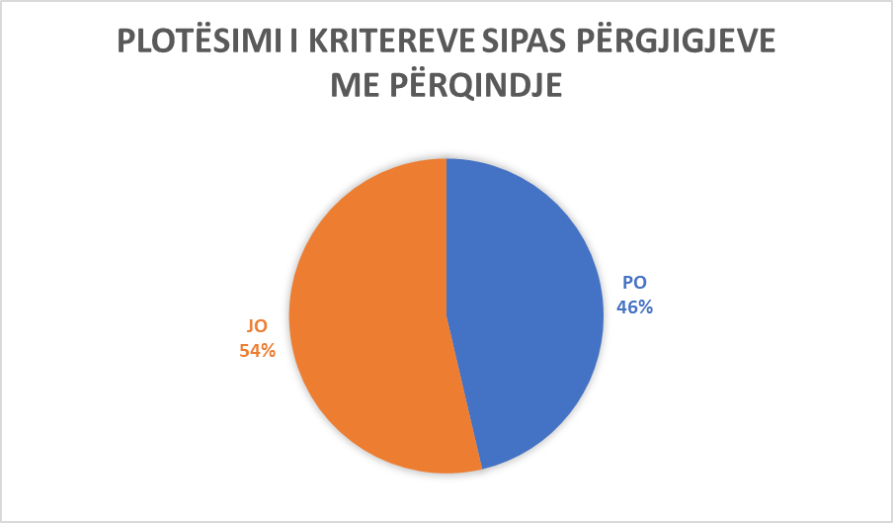

Municipality of Ferizaj/Uroševac

Municipality of Istog/Istok
Ordinal number | The answer received from the municipality | Additional comments
Question No. 1  Are there tactile surfaces on public roads in your municipality and are they built according to Article 8 of Administrative Instruction No. 33/2007 for Construction Buildings Technical Terms of Accessibility to Disabled Persons (hereinafter: AI)? | NO
Question No.2  Are the ramps in public spaces and roads built according to Article 10 of the AI? | YES | In public facilities such as municipal ones, Center for Social Welfare (CSW), in Educational Facilities.
Question No. 3  Are the stairs in the municipal public spaces built according to Article 11 of the AI? | YES | At the entrance to the facility of the Municipality of Istog. At the entrance of the Haxhi Zeka Gymnasium and in all other municipal public spaces.
Question No. 4  Do the elevators in municipal public institutions fulfill the conditions according to Article 12 of the AI? | YES | In the Facility of the Municipality of Istog.
Question No. 5  Do you have vertical lifting platforms and inclined folding lifting platforms in public institutions and do they meet the conditions according to Articles 13 and 14 of the AI? | NO
Question No. 6  Do the entrances to municipal public institutions meet the conditions according to Article 16 of the AI? | NO
Question No. 7  Do communication (communication spaces) meet conditions according to Article 17 of AI in municipal public spaces ? | NO
Question No. 8  Do WC spaces in public municipal facilities meet conditions according to Article 18 of the AI? | YES | Sports gym in Istog. The old people's home in Gjurakoc, as well as in some other FMC.
Question No. 9  Do the bathrooms meet conditions according to Article 19 of the AI in public municipal spaces? | YES | In the home for elderly people in Gjurakoc. In the city gym.
Question No. 10  Do kitchens meet conditions according to Article 20 of the AI in municipal public spaces,? | NO
Question No. 11  Do classrooms and work spaces in public municipal facilities meet conditions according to Article 21 of the AI? | YES | In educational institutions, in schools such as: Gymnasium Zeka, P.L.S.S. Bajram Curri, etc.
Question No. 12  Do Collective housing in the territory of the municipality meet the criteria according to Article 22 of the AI? | YES | The conditions foreseen according to this Administrative Instruction are always foreseen in all municipal construction permits. Graniti SH.P.K, Beni SH.P.K, Swiss LB Invest, etc.
Question No. 13  Do cafes and restaurants in the territory of the municipality meet the criteria according to Article 23 of the AI? | YES | Yes, almost all the restaurants and cafes in our Municipality as they are: Trofta, Troja, Freskia, Morea, etc.
Question No. 14  Do fitting rooms in business facilities in the territory of the municipality meet the criteria according to Article 24 of the AI? | YES | Yes, in almost all business facilities. For example, the shopping center Beni, Banana Center and Banana E, Interex, Viva Fresh, etj.
Question No. 15  Do the shower cabins in the business facilities of the municipality's territory meet the criteria according to Article 25 of the AI? | YES | Business object: Trofta, Vita, Onix, etc.
Question No. 16  Do entrances to the swimming pool in the territory of the municipality meet the criteria according to Article 26 of the AI? | YES | Yes, in Onix, in Banje.
Question No. 17  Do the seats in the tribune places in the territory of the municipality, meet the criteria according to Article 27 of the AI? | YES | Yes, sports center in Istog.
Question No. 18  Does telephone, textphone, fax and ATM in the territory of the municipality meet the criteria according to article 28 of the AI? | NO
Question No. 19  Does electrical installations in public municipal facilities meet the criteria according to article 29 of the AI? | YES | In facilities such as: Municipality building, Home for the elderly, House of culture, etc.
Question No. 20  Does door and windows handles in public municipal facilities meet the criteria according to Article 30 of the AI? | YES | Yes, Municipality building, Home for the elderly, House of culture.
Question No. 21  Do service poits in public municipal facilities meet the criteria according to article 31 of the AI? | NO
Question No. 22  Does service counter in public municipal facilities meet the criteria according to Article 32 of the AI? | YES | In the Istog Municipality building, in home for elderly persons. In the House of Culture in the city.
Question No. 23  Do the inductive areas or the transmission circle in public municipal spaces meet the criteria according to Article 33 of the AI? | NO
Question No. 24  Do notice boards in municipal public spaces meet the criteria according to Article 34 of the AI? | NO
Question No. 25  Do orientation plans for movement in public municipal buildings meet the criteria according to article 35 of the AI? | NO
Question No. 26  Do bus stations and and platforms in the territory of the municipality meet the criteria according to Article 37 of the AI? | NO
Question No. 27  Do parking spaces in collective spaces in the territory of the municipality meet the criteria according to Article 38 of the AI? | YES | In the parking lot of the Municipality of Istog. In the parking lots of business and hotel facilities.
Question No. 28  Do public surfaces - pedestrian paths in the territory of the municipality meet the criteria according to Article 39 of the AI? | NO
Question No. 29  Do the traffic lights in the territory of the municipality meet the criteria according to Article 40 of the AI? | NO
Question No. 30  Do pedestrian crossings in the territory of the municipality meet the criteria according to Article 41 of the AI? | NO
Question No. 31  Do pedestrian islands in the territory of the municipality meet the criteria according to Article 42 of the AI? | NO
Question No. 32  Do the crossroads in the territory of the municipality meet the criteria according to Article 43 of the AI? | NO
Question No. 33  In the course of designing and implementation of projects, public buildings with work purpose, do you adhere to Article 44 of the AI? | YES | It is more important to note that new construction permits are being issued, in accordance with the necessary conditions of persons with disabilities..
Question No. 34  Are the entrance gates to buildings accessible based on article 45 of the AI? | YES | Yes, in the municipal building, in the offices and civil status building, etc.
Question No. 35  Do the buildings where people with disabilities are employed meet the criteria according to Article 48 of the AI? | YES | Yes, in the facility of the Municipality, in the facility of Handikos, etc.
Question No. 36  Do cafes, restaurants, etc., meet the criteria according to Article 49 of the AI? | YES | YES, almost all cafes, restaurants have height changes for people with disabilities, such as: R. Trofta, Troja, Freskia, Natyra, etc.
Question No. 37  Do public parking lots and public garages meet the criteria according to Article 50 of the AI? | YES | Yes, as in the Municipality, in restaurants, such as: Trofta, Troja, Freskia, Natyra, etc.
Question No. 38  During the reconstruction of buildings in your municipality, do you adhere to Article 51 of the AI? | YES | Center for Social work. L.S.S. – Mithat Frasheri, etc.
Question No. 39  Is the content of the conceptual project in your municipality based on Article 55 of the AI? | YES | Yes, these technical descriptions are foreseen in all conceptual projects, as well as in urban planning, for example public institutions, business facilities, etc..
Question No. 40  Is the content of the main project in your municipality based on article 56 of the AI? | YES | Yes, in all the main projects, for example: the project for the construction of the new MFMC and that of the Center for Social Work.
Question No. 41  Is the content of the implementation project in your municipality based on Article 57 of the AI? | YES | Yes, the sports center in the Gymnasium Haxhi Zeka, CSW-, L.S.S Llukovc, etj.
Additional Comments:  (In this space you can add any other information related to the questionnaire in general) |  | “It is the commitment of the Mayor of the Municipality that during his mandate the conditions will be created for the integration of persons with disabilities”.

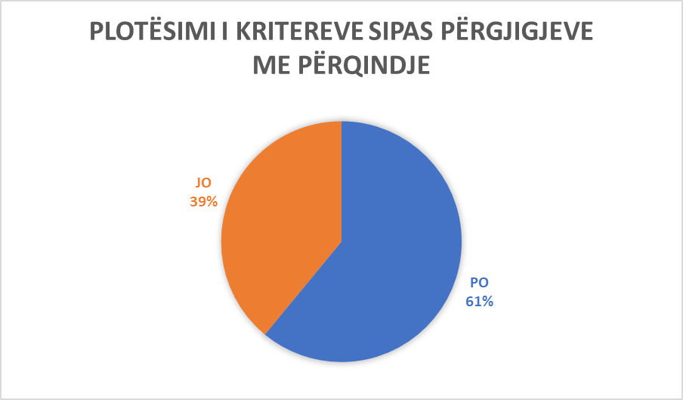

Municipality of Istog/

Municipality of Pejë/ Peć
Ordinal number | The answer received from the municipality | Additional comments
Question No. 1  Are there tactile surfaces on public roads in your municipality and are they built according to Article 8 of Administrative Instruction No. 33/2007 for Construction Buildings Technical Terms of Accessibility to Disabled Persons (hereinafter: AI)? | NO
Question No.2  Are ramps in public spaces and roads built according to Article 10 of the AI? | NO
Question No. 3  Are the stairs in the municipal public spaces built according to Article 11 of the AI? | NO
Question No. 4  Do the elevators in municipal public institutions fulfill the conditions according to Article 12 of the AI? | NO
Question No. 5  Do you have vertical lifting platforms and inclined folding lifting platforms in public institutions and do they meet the conditions according to Articles 13 and 14 of the AI? | NO
Question No. 6  Do the entrances to municipal public institutions meet the conditions according to Article 16 of the AI? | NO
Question No. 7  Do communication (communication spaces) meet conditions according to Article 17 of AI in municipal public spaces ? | NO
Question No. 8  Do WC spaces in public municipal facilities meet conditions according to Article 18 of the AI? | NO
Question No. 9  Do the bathrooms meet conditions according to Article 19 of the AI in public municipal spaces? | NO
Question No. 10  Do kitchens meet conditions according to Article 20 of the AI in municipal public spaces,? | NO
Question No. 11  Do classrooms and work spaces in public municipal facilities meet conditions according to Article 21 of the AI? | NO
Question No. 12  Do Collective housing in the territory of the municipality meet the criteria according to Article 22 of the AI? | NO
Question No. 13  Do cafes and restaurants in the territory of the municipality meet the criteria according to Article 23 of the AI? | NO
Question No. 14  Do fitting rooms in business facilities in the territory of the municipality meet the criteria according to Article 24 of the AI? | NO
Question No. 15  Do the shower cabins in the business facilities of the municipality's territory meet the criteria according to Article 25 of the AI? | NO
Question No. 16  Do entrances to the swimming pool in the territory of the municipality meet the criteria according to Article 26 of the AI? | NO
Question No. 17  Do the seats in the tribune places in the territory of the municipality, meet the criteria according to Article 27 of the AI? | NO
Question No. 18  Does telephone, textphone, fax and ATM in the territory of the municipality meet the criteria according to article 28 of the AI? | NO
Question No. 19  Does electrical installations in public municipal facilities meet the criteria according to article 29 of the AI? | NO
Question No. 20  Does door and windows handles in public municipal facilities meet the criteria according to Article 30 of the AI? | NO
Question No. 21  Do service poits in public municipal facilities meet the criteria according to article 31 of the AI? | NO
Question No. 22  Does service counter in public municipal facilities meet the criteria according to Article 32 of the AI? | NO
Question No. 23  Do the inductive areas or the transmission circle in public municipal spaces meet the criteria according to Article 33 of the AI? | NO
Question No. 24  Do notice boards in municipal public spaces meet the criteria according to Article 34 of the AI? | NO
Question No. 25  Do orientation plans for movement in public municipal buildings meet the criteria according to article 35 of the AI? | NO
Question No. 26  Do bus stations and and platforms in the territory of the municipality meet the criteria according to Article 37 of the AI? | NO
Question No. 27  Do parking spaces in collective spaces in the territory of the municipality meet the criteria according to Article 38 of the AI? | NO
Question No. 28  Do public surfaces - pedestrian paths in the territory of the municipality meet the criteria according to Article 39 of the AI? | NO
Question No. 29  Do the traffic lights in the territory of the municipality meet the criteria according to Article 40 of the AI? | NO
Question No. 30  Do pedestrian crossings in the territory of the municipality meet the criteria according to Article 41 of the AI? | NO
Question No. 31  Do pedestrian islands in the territory of the municipality meet the criteria according to Article 42 of the AI? | NO
Question No. 32  Do the crossroads in the territory of the municipality meet the criteria according to Article 43 of the AI? | NO
Question No. 33  In the course of designing and implementation of projects, public buildings with work purpose, do you adhere to Article 44 of the AI? | NO
Question No. 34  Are the entrance gates to buildings accessible based on article 45 of the AI? | NO
Question No. 35  Do the buildings where people with disabilities are employed meet the criteria according to Article 48 of the AI? | NO
Question No. 36  Do cafes, restaurants, etc., meet the criteria according to Article 49 of the AI? | NO
Question No. 37  Do public parking lots and public garages meet the criteria according to Article 50 of the AI? | NO
Question No. 38  During the reconstruction of buildings in your municipality, do you adhere to Article 51 of the AI? | YES | (no comment)
Question No. 39  Is the content of the conceptual project in your municipality based on Article 55 of the AI? | YES | (no comment)
Question No. 40  Is the content of the main project in your municipality based on article 56 of the AI? | YES | (no comment)
Question No. 41  Is the content of the implementation project in your municipality based on Article 57 of the AI? | NO
Additional Comments:  (In this space you can add any other information related to the questionnaire in general) |  | “In our municipality, Pejë, we believe that in the future we will meet the needs of the PWD (Persons with Disabilities), but we do not have the appropriate budget to meet these conditions”.

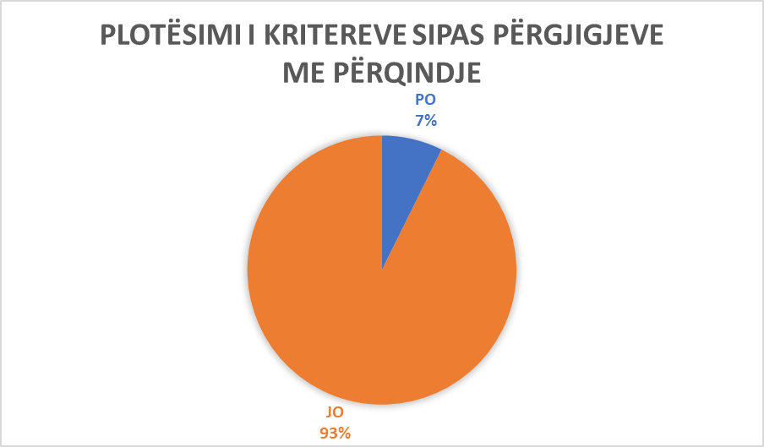

Municipality of Pejë/ Peć

Municipality of Hani i Elezit/ General Jankovič
Ordinal number | The answer received from the municipality | Additional comments
Question No. 1  Are there tactile surfaces on public roads in your municipality and are they built according to Article 8 of Administrative Instruction No. 33/2007 for Construction Buildings Technical Terms of Accessibility to Disabled Persons (hereinafter: AI)? | NO
Question No.2  Are the ramps in public spaces and roads built according to Article 10 of the AI? | NO
Question No. 3  Are the stairs in the municipal public spaces built according to Article 11 of the AI? | YES | Hani i Elezit municipality facility / educational institutions / Imri Curri Culture Center / Center for Social Work / Main Center of Family Medicine / Family Medicine Ambulance.
Question No. 4  Do the elevators in municipal public institutions fulfill the conditions according to Article 12 of the AI? | YES | Cultural Centre Imri Curri.
Question No. 5  Do you have vertical lifting platforms and inclined folding lifting platforms in public institutions and do they meet the conditions according to Articles 13 and 14 of the AI? | NO
Question No. 6  Do the entrances to municipal public institutions meet the conditions according to Article 16 of the AI? | YES | Hani i Elezit municipality facility / educational institutions (schools and nursery school) / Imri Curri Cultural Center / Center for Social Work / Main Center of Family Medicine / Family Medicine Ambulance.
Question No. 7  Do communication (communication spaces) meet conditions according to Article 17 of AI in municipal public spaces ? | YES | Hani i Elezit municipality facility / educational institutions (schools and nursery school) / Imri Curri Cultural Center / Center for Social Work / Main Center of Family Medicine / Family Medicine Ambulance.
Question No. 8  Do WC spaces in public municipal facilities meet conditions according to Article 18 of the AI? | YES | Hani i Elezit Municipal Facility / Imri Curri Cultural Center / MFMC.
Question No. 9  Do the bathrooms meet conditions according to Article 19 of the AI in public municipal spaces? | YES | Educational institutions (schools and kindergartens) / Culture Center Imri Curri.
Question No. 10  Do kitchens meet conditions according to Article 20 of the AI in municipal public spaces,? | YES | Hani i Elezit Municipality facility / Ardhmeria pre-school institution / Culture Center Imri Curri.
Question No. 11  Do classrooms and work spaces in public municipal facilities meet conditions according to Article 21 of the AI? | YES | Hani i Elezit municipality facility / educational institutions / Imri Curri Culture Center / Center for Social Work / Main Center of Family Medicine / Family Medicine Ambulance.
Question No. 12  Do Collective housing in the territory of the municipality meet the criteria according to Article 22 of the AI? | NO
Question No. 13  Do cafes and restaurants in the territory of the municipality meet the criteria according to Article 23 of the AI? | NO
Question No. 14  Do fitting rooms in business facilities in the territory of the municipality meet the criteria according to Article 24 of the AI? | YES | Educational institutions (schools and kindergartens) / Cultural Center Imri Curri.
Question No. 15  Do the shower cabins in the business facilities of the municipality's territory meet the criteria according to Article 25 of the AI? | YES | Educational institutions (schools and kindergartens) / Cultural Center Imri Curri.
Question No. 16  Do entrances to the swimming pool in the territory of the municipality meet the criteria according to Article 26 of the AI? | NO
Question No. 17  Do the seats in the tribune places in the territory of the municipality, meet the criteria according to Article 27 of the AI? | YES | Cultural Center Imri Curri.Imri Curri
Question No. 18  Does telephone, textphone, fax and ATM in the territory of the municipality meet the criteria according to article 28 of the AI? | YES | NLB Bank / Raiffeisen Bank
Question No. 19  Does electrical installations in public municipal facilities meet the criteria according to article 29 of the AI? | YES | Hani i Elezit municipality facility / educational institutions / Imri Curri Culture Center / Center for Social Work / Main Center of Family Medicine / Family Medicine Ambulance.
Question No. 20  Does door and windows handles in public municipal facilities meet the criteria according to Article 30 of the AI? | YES | Hani Elezit Municipality facility / educational institutions / Imri Curri Cultural Center / Center for Social Work / Main Center of Family Medicine / Family Medicine Ambulance.
Question No. 21  Do service poits in public municipal facilities meet the criteria according to article 31 of the AI? | YES | Hani Elezit Municipality facility / educational institutions / Imri Curri Cultural Center / Center for Social Work / Main Center of Family Medicine / Family Medicine Ambulance.
Question No. 22  Does service counter in public municipal facilities meet the criteria according to Article 32 of the AI? | NO
Question No. 23  Do the inductive areas or the transmission circle in public municipal spaces meet the criteria according to Article 33 of the AI? | NO
Question No. 24  Do notice boards in municipal public spaces meet the criteria according to Article 34 of the AI? | YES | Hani Elezit Municipality facility / educational institutions / Imri Curri Cultural Center / Center for Social Work / Main Center of Family Medicine / Family Medicine Ambulance.
Question No. 25  Do orientation plans for movement in public municipal buildings meet the criteria according to article 35 of the AI? | YES | Hani i Elezit Municipality facility / educational institutions (schools and daycare) / Main Center of Family Medicine.
Question No. 26  Do bus stations and and platforms in the territory of the municipality meet the criteria according to Article 37 of the AI? | YES | On all local roads as required.
Question No. 27  Do parking spaces in collective spaces in the territory of the municipality meet the criteria according to Article 38 of the AI? | YES | Hani i Elezit Commune facility / educational institutions (schools and nursery school) / Cultural Center Imri Curri.
Question No. 28  Do public surfaces - pedestrian paths in the territory of the municipality meet the criteria according to Article 39 of the AI? | YES | On all local roads as need.
Question No. 29  Do the traffic lights in the territory of the municipality meet the criteria according to Article 40 of the AI? | NO
Question No. 30  Do pedestrian crossings in the territory of the municipality meet the criteria according to Article 41 of the AI? | YES | On all local roads as need..
Question No. 31  Do pedestrian islands in the territory of the municipality meet the criteria according to Article 42 of the AI? | YES | Adem Jashari Street - roundabout.
Question No. 32  Do the crossroads in the territory of the municipality meet the criteria according to Article 43 of the AI? | YES | Two crossroads in the city center.
Question No. 33  In the course of designing and implementation of projects, public buildings with work purpose, do you adhere to Article 44 of the AI? | YES | Hani i Elezit Municipal Facility / Center for Social Work / Center for Equipment with Documents.
Question No. 34  Are the entrance gates to buildings accessible based on article 45 of the AI? | YES | Main Family Medicine Center / Family Medicine Clinic.
Question No. 35  Do the buildings where people with disabilities are employed meet the criteria according to Article 48 of the AI? | NO
Question No. 36  Do cafes, restaurants, etc., meet the criteria according to Article 49 of the AI? | YES | Imri Curri Cultural Center / Cafeterias, restaurants, etc.
Question No. 37  Do public parking lots and public garages meet the criteria according to Article 50 of the AI? | YES | Hani i Elezit Municipal Facility / Imri Curri Cultural Center / educational institutions (schools and daycare) / Main Center of Family Medicine.
Question No. 38  During the reconstruction of buildings in your municipality, do you adhere to Article 51 of the AI? | YES | Buildings under construction.
Question No. 39  Is the content of the conceptual project in your municipality based on Article 55 of the AI? | YES | (no comment)
Question No. 40  Is the content of the main project in your municipality based on article 56 of the AI? | YES | (no comment)
Question No. 41  Is the content of the implementation project in your municipality based on Article 57 of the AI? | YES | (no comment)
Additional Comments:  (In this space you can add any other information related to the questionnaire in general) |  | no comment.

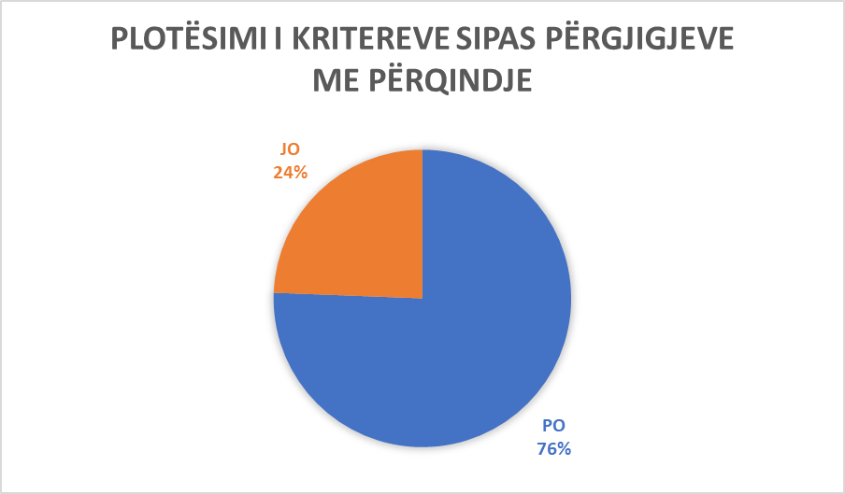

Municipality of Hani i Elezit/ General Jankovič

Municipality of Mamushë/ Mamuš

Ordinal number | The answer received from the municipality | Additional comments
Question No. 1  Are there tactile surfaces on public roads in your municipality and are they built according to Article 8 of Administrative Instruction No. 33/2007 for Construction Buildings Technical Terms of Accessibility to Disabled Persons (hereinafter: AI)? | YES | Schools –MFMC, Municipality.
Question No.2  Are the ramps in public spaces and roads built according to Article 10 of the AI? | NO | Partially.
Question No. 3  Are the stairs in the municipal public spaces built according to Article 11 of the AI? | YES | Municipality, current MFMC is one floor building.
Question No. 4  Do the elevators in municipal public institutions fulfill the conditions according to Article 12 of the AI? | NO | There is no elevator in the municipal building, but services for citizens are provided on the first floor, where there is also a ramp for wheelchair access..
Question No. 5  Do you have vertical lifting platforms and inclined folding lifting platforms in public institutions and do they meet the conditions according to Articles 13 and 14 of the AI? | YES | Municipality, school, MFMC.
Question No. 6  Do the entrances to municipal public institutions meet the conditions according to Article 16 of the AI? | YES | (no comment).
Question No. 7  Do communication (communication spaces) meet conditions according to Article 17 of AI in municipal public spaces ? | YES | (no comment).
Question No. 8  Do WC spaces in public municipal facilities meet conditions according to Article 18 of the AI? | N/A | We do not have a separate space for public WC spaces.
Question No. 9  Do the bathrooms meet conditions according to Article 19 of the AI in public municipal spaces? | N/A | There are no bathrooms in public spaces.
Question No. 10  Do kitchens meet conditions according to Article 20 of the AI in municipal public spaces,? | N/A | There are no public kitchens.
Question No. 11  Do classrooms and work spaces in public municipal facilities meet conditions according to Article 21 of the AI? | YES | (no comment).
Question No. 12  Do Collective housing in the territory of the municipality meet the criteria according to Article 22 of the AI? | N/A | There are no collective housing.
Question No. 13  Do cafes and restaurants in the territory of the municipality meet the criteria according to Article 23 of the AI? | NO | Partially.
Question No. 14  Do fitting rooms in business facilities in the territory of the municipality meet the criteria according to Article 24 of the AI? | N/A | There is no declaration that there is such a thing in the territory of Mamusha municipality.
Question No. 15  Do the shower cabins in the business facilities of the municipality's territory meet the criteria according to Article 25 of the AI? | N/A | There is not any.
Question No. 16  Do entrances to the swimming pool in the territory of the municipality meet the criteria according to Article 26 of the AI? | N/A | The municipality of Mamusha does not have a swimming pool.
Question No. 17  Do the seats in the tribune places in the territory of the municipality, meet the criteria according to Article 27 of the AI? | N/A | There are no tribune places.
Question No. 18  Does telephone, textphone, fax and ATM in the territory of the municipality meet the criteria according to article 28 of the AI? | N/A | There is no ATM in municipal assembly of Mamush, phones are out of order.
Question No. 19  Does electrical installations in public municipal facilities meet the criteria according to article 29 of the AI? | YES | (no comment)
Question No. 20  Does door and windows handles in public municipal facilities meet the criteria according to Article 30 of the AI? | NO | Partially.
Question No. 21  Do service poits in public municipal facilities meet the criteria according to article 31 of the AI? | NO | Partially, but that the services are performed efficiently for all persons.
Question No. 22  Does service counter in public municipal facilities meet the criteria according to Article 32 of the AI? | NO | Partially.
Question No. 23  Do the inductive areas or the transmission circle in public municipal spaces meet the criteria according to Article 33 of the AI? | N/A
Question No. 24  Do notice boards in municipal public spaces meet the criteria according to Article 34 of the AI? | YES | But in most cases the announcements are made on social networks.
Question No. 25  Do orientation plans for movement in public municipal buildings meet the criteria according to article 35 of the AI? | YES | (no comment)
Question No. 26  Do bus stations and and platforms in the territory of the municipality meet the criteria according to Article 37 of the AI? | YES | (no comment)
Question No. 27  Do parking spaces in collective spaces in the territory of the municipality meet the criteria according to Article 38 of the AI? | YES | (no comment)
Question No. 28  Do public surfaces - pedestrian paths in the territory of the municipality meet the criteria according to Article 39 of the AI? | NO | Partially.
Question No. 29  Do the traffic lights in the territory of the municipality meet the criteria according to Article 40 of the AI? | N/A | There is no traffic light.
Question No. 30  Do pedestrian crossings in the territory of the municipality meet the criteria according to Article 41 of the AI? | YES | (no comment)
Question No. 31  Do pedestrian islands in the territory of the municipality meet the criteria according to Article 42 of the AI? | YES | (no comment)
Question No. 32  Do the crossroads in the territory of the municipality meet the criteria according to Article 43 of the AI? | NO | Partially.
Question No. 33  In the course of designing and implementation of projects, public buildings with work purpose, do you adhere to Article 44 of the AI? | NO | Partially.
Question No. 34  Are the entrance gates to buildings accessible based on article 45 of the AI? | YES | (no comment)
Question No. 35  Do the buildings where people with disabilities are employed meet the criteria according to Article 48 of the AI? | NO | Partially.
Question No. 36  Do cafes, restaurants, etc., meet the criteria according to Article 49 of the AI? | YES | (no comment)
Question No. 37  Do public parking lots and public garages meet the criteria according to Article 50 of the AI? | N/A | There is no public garage.
Question No. 38  During the reconstruction of buildings in your municipality, do you adhere to Article 51 of the AI? | YES | (no comment)
Question No. 39  Is the content of the conceptual project in your municipality based on Article 55 of the AI? | YES | (no comment)
Question No. 40  Is the content of the main project in your municipality based on article 56 of the AI? | YES | (no comment)
Question No. 41  Is the content of the implementation project in your municipality based on Article 57 of the AI? | YES | (no comment)
Additional Comments:  (In this space you can add any other information related to the questionnaire in general) |  | No comment.

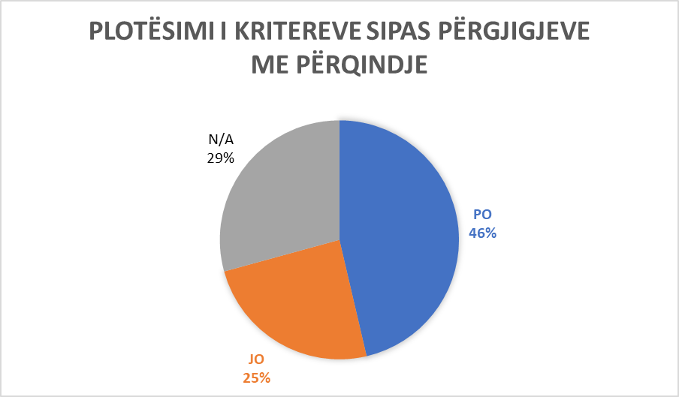

Municipality of Mamushë/Mamuš

Municipality of Viti
Ordinal number | The answer received from the municipality | Additional comments
Question No. 1  Are there tactile surfaces on public roads in your municipality and are they built according to Article 8 of Administrative Instruction No. 33/2007 for Construction Buildings Technical Terms of Accessibility to Disabled Persons (hereinafter: AI)? | NO
Question No.2  Are the ramps in public spaces and roads built according to Article 10 of the AI? | YES | In the central part of the city. The two municipal facilities. House of Culture. MFMC in Viti, the Health Center in Pozhoran and the ambulances in the villages.
Question No. 3  Are the stairs in the municipal public spaces built according to Article 11 of the AI? | YES | In municipal facilities. House of Culture. The MFMCs of the territory of the municipality.
Question No. 4  Do the elevators in municipal public institutions fulfill the conditions according to Article 12 of the AI? | YES | The object of the new municipality. In the MFMC in Viti, it is under construction.
Question No. 5  Do you have vertical lifting platforms and inclined folding lifting platforms in public institutions and do they meet the conditions according to Articles 13 and 14 of the AI? | NO
Question No. 6  Do the entrances to municipal public institutions meet the conditions according to Article 16 of the AI? | NO | Municipal facilities have access elements, but not according to all the conditions of Article 16 of the AI. Educational facilities of the municipality.
Question No. 7  Do communication (communication spaces) meet conditions according to Article 17 of AI in municipal public spaces ? | YES | Municipal facilities. House of Culture. MFMC, Ambulances of the municipality. Basic Court in Viti. Police station. Educational facilities.
Question No. 8  Do WC spaces in public municipal facilities meet conditions according to Article 18 of the AI? | YES | New Municipality. Pozhoran Health House. Basic Court in Viti. Old facilities do not meet the conditions.
Question No. 9  Do the bathrooms meet conditions according to Article 19 of the AI in public municipal spaces? | NO
Question No. 10  Do kitchens meet conditions according to Article 20 of the AI in municipal public spaces,? | YES | The object of the municipality of New. The mayor's office. Health center - Pozhoran.
Question No. 11  Do classrooms and work spaces in public municipal facilities meet conditions according to Article 21 of the AI? | YES | Hall of the Municipal Assembly. The schools of our municipality. Hall of the President's Office.
Question No. 12  Do Collective housing in the territory of the municipality meet the criteria according to Article 22 of the AI? | YES | New collective residential buildings, Obj. Arbri, Inter com, Mobimo Construction.
Question No. 13  Do cafes and restaurants in the territory of the municipality meet the criteria according to Article 23 of the AI? | YES | They have the access part, but not all of them: Rio, Togo, Baron, N’za, Lindi i Ri, Mediteran, Dajti, etj.
Question No. 14  Do fitting rooms in business facilities in the territory of the municipality meet the criteria according to Article 24 of the AI? | YES | The 'Classic' boutique. Premium V sh.p.k. – partially.
Question No. 15  Do the shower cabins in the business facilities of the municipality's territory meet the criteria according to Article 25 of the AI? | N/A | We lack functional cabins.
Question No. 16  Do entrances to the swimming pool in the territory of the municipality meet the criteria according to Article 26 of the AI? | N/A | Currently, we do not have functional swimming pools in our municipality.
Question No. 17  Do the seats in the tribune places in the territory of the municipality, meet the criteria according to Article 27 of the AI? | NO
Question No. 18  Does telephone, textphone, fax and ATM in the territory of the municipality meet the criteria according to article 28 of the AI? | YES | TEB Bank, Raiffaisen Bank, BKT, PTK.
Question No. 19  Does electrical installations in public municipal facilities meet the criteria according to article 29 of the AI? | YES | The building of the new municipality. Basic Court in Viti.
Question No. 20  Does door and windows handles in public municipal facilities meet the criteria according to Article 30 of the AI? | YES | The building of the new municipality. Basic Court in Viti. All Banks.
Question No. 21  Do service poits in public municipal facilities meet the criteria according to article 31 of the AI? | YES | PTK, Medical center in Pozhoran. TEB Bank.
Question No. 22  Does service counter in public municipal facilities meet the criteria according to Article 32 of the AI? | NO
Question No. 23  Do the inductive areas or the transmission circle in public municipal spaces meet the criteria according to Article 33 of the AI? | NO
Question No. 24  Do notice boards in municipal public spaces meet the criteria according to Article 34 of the AI? | YES | Building of the Basic Court in Viti. New municipality building. PTK. MFMC- Viti.
Question No. 25  Do orientation plans for movement in public municipal buildings meet the criteria according to article 35 of the AI? | NO
Question No. 26  Do bus stations and and platforms in the territory of the municipality meet the criteria according to Article 37 of the AI? | YES | Bus station – Viti. Stopping at “mirror”.
Question No. 27  Do parking spaces in collective spaces in the territory of the municipality meet the criteria according to Article 38 of the AI? | YES | All collective spaces have parking spaces for PWDs.
Question No. 28  Do public surfaces - pedestrian paths in the territory of the municipality meet the criteria according to Article 39 of the AI? | YES | All pedestrian paths in the territory of the municipality are accessible.
Question No. 29  Do the traffic lights in the territory of the municipality meet the criteria according to Article 40 of the AI? | NO | The traffic lights at the Pozhoran crossroads are not active.
Question No. 30  Do pedestrian crossings in the territory of the municipality meet the criteria according to Article 41 of the AI? | YES | All pedestrian crossings are accessible for PWDs.
Question No. 31  Do pedestrian islands in the territory of the municipality meet the criteria according to Article 42 of the AI? | YES | All pedestrian islands are PWD accessible.
Question No. 32  Do the crossroads in the territory of the municipality meet the criteria according to Article 43 of the AI? | YES | Crossroads at Pozhoran street. Roundabout at the Mosque.
Question No. 33  In the course of designing and implementation of projects, public buildings with work purpose, do you adhere to Article 44 of the AI? | YES | Almost all public buildings for work purposes comply with the article 44.
Question No. 34  Are the entrance gates to buildings accessible based on article 45 of the AI? | YES | The object of the old municipality and the new municipality. MFMC in Viti. Basic Court in Viti. Collective housing - new constructions.
Question No. 35  Do the buildings where people with disabilities are employed meet the criteria according to Article 48 of the AI? | YES | New municipal building.
Question No. 36  Do cafes, restaurants, etc., meet the criteria according to Article 49 of the AI? | NO | Restaurant ‘Lindi i Ri’, ‘Dajti’, ‘Musa’ (all partially).
Question No. 37  Do public parking lots and public garages meet the criteria according to Article 50 of the AI? | YES | Public parking lots meet the criteria throughout the territory of the municipality with the relevant signage, while we do not have public garages.
Question No. 38  During the reconstruction of buildings in your municipality, do you adhere to Article 51 of the AI? | YES | The two buildings of the old municipality. House of Culture.
Question No. 39  Is the content of the conceptual project in your municipality based on Article 55 of the AI? | YES | Public municipal facilities. Residential and business facilities.
Question No. 40  Is the content of the main project in your municipality based on article 56 of the AI? | YES | Collective housing facilities.
Question No. 41  Is the content of the implementation project in your municipality based on Article 57 of the AI? | NO
Additional Comments:  (In this space you can add any other information related to the questionnaire in general) |  | “The questionnaire was completed in writing as well as a physical copy was delivered to us, we visited the mentioned locations as much as possible. We also took measurements as much as we could, we also received some answers over the phone. We tried to fill out this questionnaire correctly and we were forced to fill in some questions with alternatives not in their entirety, due to the fact that some Municipal Facilities partially meet the criteria from Administrative Instruction no. 33/2007”.

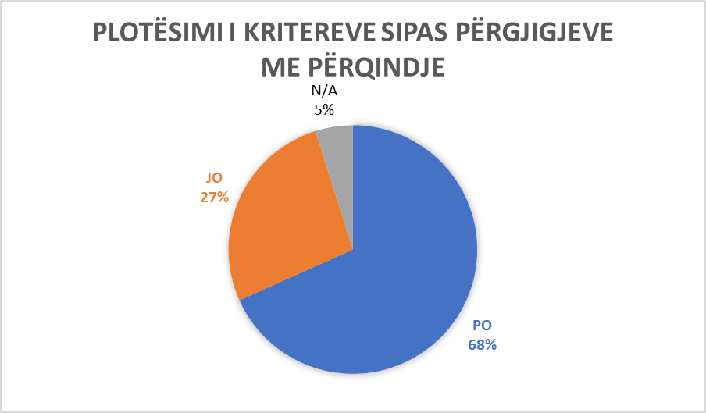

Municipality of Viti

Municipality of Dragashit/ Dragaš
Ordinal number | The answer received from the municipality | Additional comments
Question No. 1  Are there tactile surfaces on public roads in your municipality and are they built according to Article 8 of Administrative Instruction No. 33/2007 for Construction Buildings Technical Terms of Accessibility to Disabled Persons (hereinafter: AI)? | NO
Question No.2  Are the ramps in public spaces and roads built according to Article 10 of the AI? | NO
Question No. 3  Are the stairs in the municipal public spaces built according to Article 11 of the AI? | PO | Municipality building. MFMC. school.
Question No. 4  Do the elevators in municipal public institutions fulfill the conditions according to Article 12 of the AI? | NO
Question No. 5  Do you have vertical lifting platforms and inclined folding lifting platforms in public institutions and do they meet the conditions according to Articles 13 and 14 of the AI? | NO
Question No. 6  Do the entrances to municipal public institutions meet the conditions according to Article 16 of the AI? | YES | The facility of the municipality, MFMC,CSW, Post Office, Civil Affairs, Libraries, Forestry Facility, FMAs, FMCs, Employment Office, 95% of the schools in the municipality of Dragash have built entrances.
Question No. 7  Do communication (communication spaces) meet conditions according to Article 17 of AI in municipal public spaces ? | YES | Municipality building. MFMC. CSW. Civic Centers, Schools, etc.
Question No. 8  Do WC spaces in public municipal facilities meet conditions according to Article 18 of the AI? | NO
Question No. 9  Do the bathrooms meet conditions according to Article 19 of the AI in public municipal spaces? | NO
Question No. 10  Do kitchens meet conditions according to Article 20 of the AI in municipal public spaces,? | NO
Question No. 11  Do classrooms and work spaces in public municipal facilities meet conditions according to Article 21 of the AI? | YES | Municipal building. MFMC. CSW. Schools, etc.
Question No. 12  Do Collective housing in the territory of the municipality meet the criteria according to Article 22 of the AI? | NO
Question No. 13  Do cafes and restaurants in the territory of the municipality meet the criteria according to Article 23 of the AI? | NO | Partially.
Question No. 14  Do fitting rooms in business facilities in the territory of the municipality meet the criteria according to Article 24 of the AI? | NO | Partially.
Question No. 15  Do the shower cabins in the business facilities of the municipality's territory meet the criteria according to Article 25 of the AI? | NO | Partially.
Question No. 16  Do entrances to the swimming pool in the territory of the municipality meet the criteria according to Article 26 of the AI? | NO
Question No. 17  Do the seats in the tribune places in the territory of the municipality, meet the criteria according to Article 27 of the AI? | N/A
Question No. 18  Does telephone, textphone, fax and ATM in the territory of the municipality meet the criteria according to article 28 of the AI? | NO
Question No. 19  Does electrical installations in public municipal facilities meet the criteria according to article 29 of the AI? | NO
Question No. 20  Does door and windows handles in public municipal facilities meet the criteria according to Article 30 of the AI? | NO | Partially.
Question No. 21  Do service poits in public municipal facilities meet the criteria according to article 31 of the AI? | YES | Municipal building. MFMC. CSW. Civic Centers, Schools, etc.
Question No. 22  Does service counter in public municipal facilities meet the criteria according to Article 32 of the AI? | YES | Municipal building.
Question No. 23  Do the inductive areas or the transmission circle in public municipal spaces meet the criteria according to Article 33 of the AI? | NO
Question No. 24  Do notice boards in municipal public spaces meet the criteria according to Article 34 of the AI? | YES | Municipal building. MFMC. CSW. Civic Centers, Schools, etc.
Question No. 25  Do orientation plans for movement in public municipal buildings meet the criteria according to article 35 of the AI? | YES | Municipal building. MFMC.
Question No. 26  Do bus stations and and platforms in the territory of the municipality meet the criteria according to Article 37 of the AI? | NO
Question No. 27  Do parking spaces in collective spaces in the territory of the municipality meet the criteria according to Article 38 of the AI? | NO
Question No. 28  Do public surfaces - pedestrian paths in the territory of the municipality meet the criteria according to Article 39 of the AI? | NO | Partially.
Question No. 29  Do the traffic lights in the territory of the municipality meet the criteria according to Article 40 of the AI? | NO
Question No. 30  Do pedestrian crossings in the territory of the municipality meet the criteria according to Article 41 of the AI? | NO | Partially.
Question No. 31  Do pedestrian islands in the territory of the municipality meet the criteria according to Article 42 of the AI? | NO | Partially.
Question No. 32  Do the crossroads in the territory of the municipality meet the criteria according to Article 43 of the AI? | NO
Question No. 33  In the course of designing and implementation of projects, public buildings with work purpose, do you adhere to Article 44 of the AI? | YES | (no comment )
Question No. 34  Are the entrance gates to buildings accessible based on article 45 of the AI? | YES | Municipality building. MFMC. CSW. FMAs, FMCs, CSW, Civic Centers Libraries, Schools, etc.
Question No. 35  Do the buildings where people with disabilities are employed meet the criteria according to Article 48 of the AI? | YES | Employment Office.
Question No. 36  Do cafes, restaurants, etc., meet the criteria according to Article 49 of the AI? | NO
Question No. 37  Do public parking lots and public garages meet the criteria according to Article 50 of the AI? | YES | Municipality building. MFMC, FMAs, FMCs, CSW, Schools, etc.
Question No. 38  During the reconstruction of buildings in your municipality, do you adhere to Article 51 of the AI? | YES | (no comment)
Question No. 39  Is the content of the conceptual project in your municipality based on Article 55 of the AI? | YES | (no comment)
Question No. 40  Is the content of the main project in your municipality based on article 56 of the AI? | YES | (no comment)
Question No. 41  Is the content of the implementation project in your municipality based on Article 57 of the AI? | YES | (no comment)
Additional Comments:  (In this space you can add any other information related to the questionnaire in general) |  | (no comment.

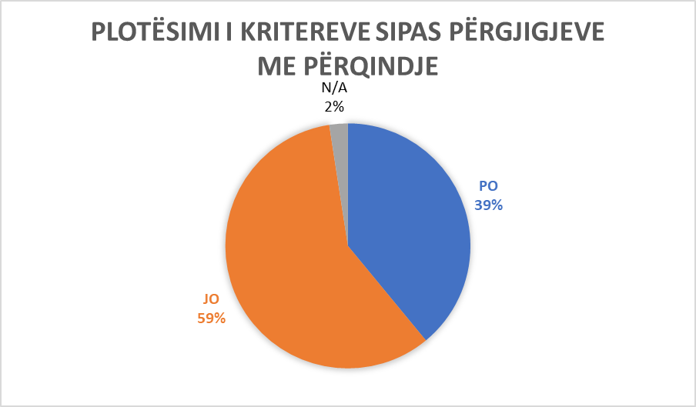

Municipality of Dragash/ Dragaš

Municipality of Rahovec/ Orahovac
Ordinal number | The answer received from the municipality | Additional comments
Question No. 1  Are there tactile surfaces on public roads in your municipality and are they built according to Article 8 of Administrative Instruction No. 33/2007 for Construction Buildings Technical Terms of Accessibility to Disabled Persons (hereinafter: AI)? | YES | Rahovec, in schools, in other institutions, FMA, MFMC, houses of culture, sports centers.
Question No.2  Are ramps in public spaces and roads built according to Article 10 of the AI? | YES | Rahovec, in Schools.
Question No. 3  Are the stairs in the municipal public spaces built according to Article 11 of the AI? | YES | Municipality, House of Culture, Gym, MFMC, FMA, FMC.
Question No. 4  Do the elevators in municipal public institutions fulfill the conditions according to Article 12 of the AI? | YES | MFMC, kindergarten, Ratkoc, Krushe e Madhe (primary school), school ‘Sadedim Hajda’.
Question No. 5  Do you have vertical lifting platforms and inclined folding lifting platforms in public institutions and do they meet the conditions according to Articles 13 and 14 of the AI? | NO
Question No. 6  Do the entrances to municipal public institutions meet the conditions according to Article 16 of the AI? | YES | City and settlements.
Question No. 7  Do communication (communication spaces) meet conditions according to Article 17 of AI in municipal public spaces ? | YES | Rahovec.
Question No. 8  Do WC spaces in public municipal facilities meet conditions according to Article 18 of the AI? | NO
Question No. 9  Do the bathrooms meet conditions according to Article 19 of the AI in public municipal spaces? | NO
Question No. 10  Do kitchens meet conditions according to Article 20 of the AI in municipal public spaces,? | NO
Question No. 11  Do classrooms and work spaces in public municipal facilities meet conditions according to Article 21 of the AI? | YES | In all schools, in the municipality, at MFMC, FMA, FMC.
Question No. 12  Do Collective housing in the territory of the municipality meet the criteria according to Article 22 of the AI? | NO
Question No. 13  Do cafes and restaurants in the territory of the municipality meet the criteria according to Article 23 of the AI? | YES | In all settlements.
Question No. 14  Do fitting rooms in business facilities in the territory of the municipality meet the criteria according to Article 24 of the AI? | NO
Question No. 15  Do the shower cabins in the business facilities of the municipality's territory meet the criteria according to Article 25 of the AI? | NO
Question No. 16  Do entrances to the swimming pool in the territory of the municipality meet the criteria according to Article 26 of the AI? | NO
Question No. 17  Do the seats in the tribune places in the territory of the municipality, meet the criteria according to Article 27 of the AI? | YES | Gym facilities, Stadium.
Question No. 18  Does telephone, textphone, fax and ATM in the territory of the municipality meet the criteria according to article 28 of the AI? | YES | Post.
Question No. 19  Does electrical installations in public municipal facilities meet the criteria according to article 29 of the AI? | YES | Municipality.
Question No. 20  Does door and windows handles in public municipal facilities meet the criteria according to Article 30 of the AI? | YES | Municipality, in public institutions.
Question No. 21  Do service poits in public municipal facilities meet the criteria according to article 31 of the AI? | YES | Municipality, other institutions, school, nursery school.
Question No. 22  Does service counter in public municipal facilities meet the criteria according to Article 32 of the AI? | NO | Partially.
Question No. 23  Do the inductive areas or the transmission circle in public municipal spaces meet the criteria according to Article 33 of the AI? | YES | Municipality, Gym facilities, House of Culture.
Question No. 24  Do notice boards in municipal public spaces meet the criteria according to Article 34 of the AI? | YES | Yes in institutions.
Question No. 25  Do orientation plans for movement in public municipal buildings meet the criteria according to article 35 of the AI? | YES | Municipality, Gym facilities, MFMC.
Question No. 26  Do bus stations and and platforms in the territory of the municipality meet the criteria according to Article 37 of the AI? | YES | On some regional roads within the territory of the municipality.
Question No. 27  Do parking spaces in collective spaces in the territory of the municipality meet the criteria according to Article 38 of the AI? | YES | In the city, in institutions, in the municipality, school, etc.
Question No. 28  Do public surfaces - pedestrian paths in the territory of the municipality meet the criteria according to Article 39 of the AI? | NO
Question No. 29  Do the traffic lights in the territory of the municipality meet the criteria according to Article 40 of the AI? | YES | Rahovec, at two crossroads.
Question No. 30  Do pedestrian crossings in the territory of the municipality meet the criteria according to Article 41 of the AI? | YES | In Rahovec in main road.
Question No. 31  Do pedestrian islands in the territory of the municipality meet the criteria according to Article 42 of the AI? | YES | In the city.
Question No. 32  Do the crossroads in the territory of the municipality meet the criteria according to Article 43 of the AI? | YES | In the city.
Question No. 33  In the course of designing and implementation of projects, public buildings with work purpose, do you adhere to Article 44 of the AI? | YES | In the city, partially in some areas.
Question No. 34  Are the entrance gates to buildings accessible based on article 45 of the AI? | NO | Partially.
Question No. 35  Do the buildings where people with disabilities are employed meet the criteria according to Article 48 of the AI? | YES | MFMC, in some institutions.
Question No. 36  Do cafes, restaurants, etc., meet the criteria according to Article 49 of the AI? | NO | Yes, partially.
Question No. 37  Do public parking lots and public garages meet the criteria according to Article 50 of the AI? | YES | In some locations, city and town.
Question No. 38  During the reconstruction of buildings in your municipality, do you adhere to Article 51 of the AI? | NO | Partially.
Question No. 39  Is the content of the conceptual project in your municipality based on Article 55 of the AI? | YES | In each Project.
Question No. 40  Is the content of the main project in your municipality based on article 56 of the AI? | YES | In every construction project.
Question No. 41  Is the content of the implementation project in your municipality based on Article 57 of the AI? | YES | In MFMC.
Additional Comments:  (In this space you can add any other information related to the questionnaire in general) |  | No comment.

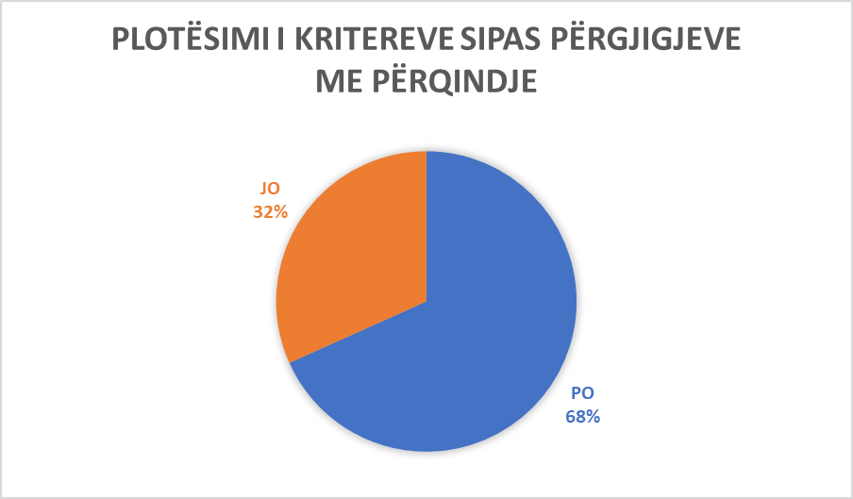

Municipality of Rahovec/ Orahovac

Municipality of Junik
Ordinal number | The answer received from the municipality | Additional comments
Question No. 1  Are there tactile surfaces on public roads in your municipality and are they built according to Article 8 of Administrative Instruction No. 33/2007 for Construction Buildings Technical Terms of Accessibility to Disabled Persons (hereinafter: AI)? | NO
Question No.2  Are the ramps in public spaces and roads built according to Article 10 of the AI? | YES | Ramp in the parking lot of the Municipality (object), at MFMC.
Question No. 3  Are the stairs in the municipal public spaces built according to Article 11 of the AI? | YES | Yes, in the Municipality building. The 'EU for all' project is in progress, where the Municipality of Junik is the beneficiary of this project, for the improvement of the conditions for the access of persons with disabilities to the municipal facilities. We will look at the possibilities for improving these conditions in all public spaces. In MFMC partly, in schools partly.
Question No. 4  Do the elevators in municipal public institutions fulfill the conditions according to Article 12 of the AI? | YES | Yes, the elevator that will be functional in the municipality facility, from the "EU for all" project.
Question No. 5  Do you have vertical lifting platforms and inclined folding lifting platforms in public institutions and do they meet the conditions according to Articles 13 and 14 of the AI? | NO
Question No. 6  Do the entrances to municipal public institutions meet the conditions according to Article 16 of the AI? | YES | Yes, in the municipality facility, in the primary school, in the gymnasium (high school), in the MFMC, in the CSW, the fire department facility.
Question No. 7  Do communication (communication spaces) meet conditions according to Article 17 of AI in municipal public spaces ? | YES | Yes, in the municipality's facility, in the MFMC, in the CSW, in schools.
Question No. 8  Do WC spaces in public municipal facilities meet conditions according to Article 18 of the AI? | YES | Yes, in the facility of the municipality, in the MFMC, in the Primary Lower Secondary Sschool.
Question No. 9  Do the bathrooms meet conditions according to Article 19 of the AI in public municipal spaces? | N/A | We do not have bathrooms in public communal spaces.
Question No. 10  Do kitchens meet conditions according to Article 20 of the AI in municipal public spaces,? | N/A | We do not have kitchens in communal public spaces.
Question No. 11  Do classrooms and work spaces in public municipal facilities meet conditions according to Article 21 of the AI? | YES | Yes, in the municipality facility, in schools partially.
Question No. 12  Do Collective housing in the territory of the municipality meet the criteria according to Article 22 of the AI? | YES | Collective housing meets the conditions (close to the Police) according to Article 22 of the Directive. Apartments: Tilia, Joos – near the school.
Question No. 13  Do cafes and restaurants in the territory of the municipality meet the criteria according to Article 23 of the AI? | YES | Partially, some of the restaurants meet these conditions according to Article 23 of the Administrative Instruction. Restaurant ‘Oda’, ‘Moronica’, ‘Trofta’, ‘Delfini’, ‘Te Besi’.
Question No. 14  Do fitting rooms in business facilities in the territory of the municipality meet the criteria according to Article 24 of the AI? | NO
Question No. 15  Do the shower cabins in the business facilities of the municipality's territory meet the criteria according to Article 25 of the AI? | NO
Question No. 16  Do entrances to the swimming pool in the territory of the municipality meet the criteria according to Article 26 of the AI? | N/A | We do not have a swimming pool in the territory of the municipality.
Question No. 17  Do the seats in the tribune places in the territory of the municipality, meet the criteria according to Article 27 of the AI? | NO
Question No. 18  Does telephone, textphone, fax and ATM in the territory of the municipality meet the criteria according to article 28 of the AI? | YES | All ATMs located in the territory of the municipality meet these conditions.
Question No. 19  Does electrical installations in public municipal facilities meet the criteria according to article 29 of the AI? | YES | In all facilities of public institutions, partially.
Question No. 20  Does door and windows handles in public municipal facilities meet the criteria according to Article 30 of the AI? | NO | In part, the handles are only on the entrance doors of the buildings, while the window handles do not meet the conditions according to Article 30 of the Directive.
Question No. 21  Do service poits in public municipal facilities meet the criteria according to article 31 of the AI? | YES | Yes, all counters of public facilities meet the criteria according to Article 31 of the Administrative Instruction. Included here: the counter of the municipal facility, the counter at the MFMC - partially.
Question No. 22  Does service counter in public municipal facilities meet the criteria according to Article 32 of the AI? | NO
Question No. 23  Do the inductive areas or the transmission circle in public municipal spaces meet the criteria according to Article 33 of the AI? | NO
Question No. 24  Do notice boards in municipal public spaces meet the criteria according to Article 34 of the AI? | YES | Yes, notice boards are not placed at very high heights, in the municipal building, in the MFMC, in schools.
Question No. 25  Do orientation plans for movement in public municipal buildings meet the criteria according to article 35 of the AI? | NO
Question No. 26  Do bus stations and and platforms in the territory of the municipality meet the criteria according to Article 37 of the AI? | NO | Partially.
Question No. 27  Do parking spaces in collective spaces in the territory of the municipality meet the criteria according to Article 38 of the AI? | YES | In all parking lots of public facilities, parking spaces for disabled people are signaled.
Question No. 28  Do public surfaces - pedestrian paths in the territory of the municipality meet the criteria according to Article 39 of the AI? | YES | Public surfaces – pedestrian paths, the path around the Erenik River partially meet the conditions for the movement of people with disabilities.
Question No. 29  Do the traffic lights in the territory of the municipality meet the criteria according to Article 40 of the AI? | N/A | We don't have traffic lights in our municipality.
Question No. 30  Do pedestrian crossings in the territory of the municipality meet the criteria according to Article 41 of the AI? | NO | The pedestrian crossings found in the center of Junik partially meet the criteria from Article 41 of the Administrative Instruction.
Question No. 31  Do pedestrian islands in the territory of the municipality meet the criteria according to Article 42 of the AI? | NO
Question No. 32  Do the crossroads in the territory of the municipality meet the criteria according to Article 43 of the AI? | NO | On the main roads, they partially meet the criteria according to Article 43 of the Administrative Instruction.
Question No. 33  In the course of designing and implementation of projects, public buildings with work purpose, do you adhere to Article 44 of the AI? | NO | Partially.
Question No. 34  Are the entrance gates to buildings accessible based on article 45 of the AI? | YES | In all public facilities.
Question No. 35  Do the buildings where people with disabilities are employed meet the criteria according to Article 48 of the AI? | YES | In the facilities of public institutions, in the facility of the municipality, in schools, in the MFMC.
Question No. 36  Do cafes, restaurants, etc., meet the criteria according to Article 49 of the AI? | NO | Partly, since they don't have WC access.
Question No. 37  Do public parking lots and public garages meet the criteria according to Article 50 of the AI? | YES | Some of the public parking lots meet the criteria set forth in Article 50 of the Directive.
Question No. 38  During the reconstruction of buildings in your municipality, do you adhere to Article 51 of the AI? | YES | Yes, during the redeployment of the facility for the public daycare, we complied with Article 51 of the Directive.
Question No. 39  Is the content of the conceptual project in your municipality based on Article 55 of the AI? | YES | (no comment )
Question No. 40  Is the content of the main project in your municipality based on article 56 of the AI? | NO | Partially.
Question No. 41  Is the content of the implementation project in your municipality based on Article 57 of the AI? | NO | Partially.
Additional Comments:  (In this space you can add any other information related to the questionnaire in general) |  | “The municipal facility is a public space/public institution that meets all the criteria according to Administrative Instruction no. 33/2007, since the Municipality of Junik is a beneficiary of the 'EU for all' project financed by the EU office in Kosovo for the improvement of conditions for the access of persons with disabilities to the facility of the municipality. We will try, through various projects, to ensure that in all public spaces/public institutions the conditions are created for the easier access of persons with disabilities”.
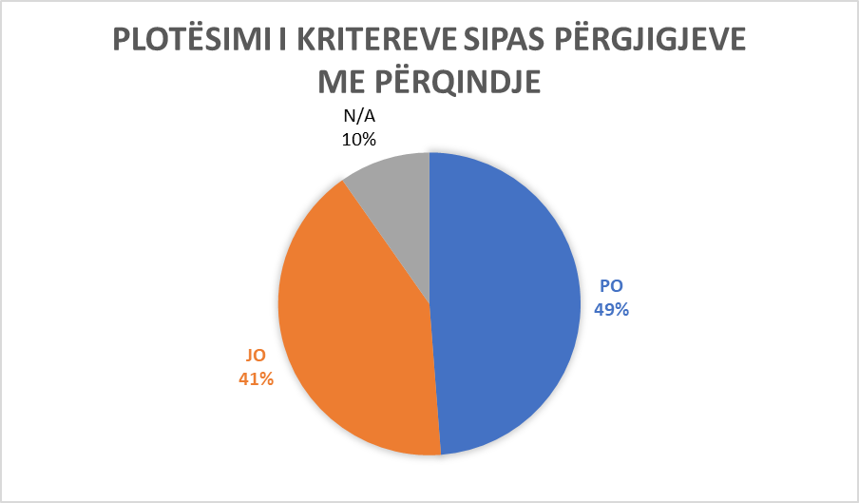

Municipality of Junik

Municipality of Kllokot/ Klokot
Ordinal number | The answer received from the municipality | Additional comments
Question No. 1  Are there tactile surfaces on public roads in your municipality and are they built according to Article 8 of Administrative Instruction No. 33/2007 for Construction Buildings Technical Terms of Accessibility to Disabled Persons (hereinafter: AI)? | NO | There are ramps in public buildings, while there are none on public roads. There are ramps at the entrance of municipal buildings and schools.
Question No.2  Are the ramps in public spaces and roads built according to Article 10 of the AI? | YES | Ramps on external surfaces exist and are used as access elements to surfaces of different heights in buildings.
Question No. 3  Are the stairs in the municipal public spaces built according to Article 11 of the AI? | YES | Stairs in municipal public spaces in new buildings are built in accordance with the mentioned article AI 11, while in old buildings they are not in accordance with article 11 of the AI.
Question No. 4  Do the elevators in municipal public institutions fulfill the conditions according to Article 12 of the AI? | NO
Question No. 5  Do you have vertical lifting platforms and inclined folding lifting platforms in public institutions and do they meet the conditions according to Articles 13 and 14 of the AI? | NO
Question No. 6  Do the entrances to municipal public institutions meet the conditions according to Article 16 of the AI? | YES | Municipal buildings, family medicine center, kindergarten, cultural center.
Question No. 7  Do communication (communication spaces) meet conditions according to Article 17 of AI in municipal public spaces ? | NO
Question No. 8  Do WC spaces in public municipal facilities meet conditions according to Article 18 of the AI? | NO
Question No. 9  Do the bathrooms meet conditions according to Article 19 of the AI in public municipal spaces? | NO
Question No. 10  Do kitchens meet conditions according to Article 20 of the AI in municipal public spaces,? | NO
Question No. 11  Do classrooms and work spaces in public municipal facilities meet conditions according to Article 21 of the AI? | YES | All school facilities in the territory of our municipality.
Question No. 12  Do Collective housing in the territory of the municipality meet the criteria according to Article 22 of the AI? | YES | Yes, in the facilities of our wellness spa in our municipality.
Question No. 13  Do cafes and restaurants in the territory of the municipality meet the criteria according to Article 23 of the AI? | YES | Pera com, Viva Fres, Tina petrol, Seb, Hotel Niti etc.
Question No. 14  Do fitting rooms in business facilities in the territory of the municipality meet the criteria according to Article 24 of the AI? | NO
Question No. 15  Do the shower cabins in the business facilities of the municipality's territory meet the criteria according to Article 25 of the AI? | NO
Question No. 16  Do entrances to the swimming pool in the territory of the municipality meet the criteria according to Article 26 of the AI? | NO
Question No. 17  Do the seats in the tribune places in the territory of the municipality, meet the criteria according to Article 27 of the AI? | NO
Question No. 18  Does telephone, textphone, fax and ATM in the territory of the municipality meet the criteria according to article 28 of the AI? | NO
Question No. 19  Does electrical installations in public municipal facilities meet the criteria according to article 29 of the AI? | NO | All facilities meet the criteria from Article 29 A.I.
Question No. 20  Does door and windows handles in public municipal facilities meet the criteria according to Article 30 of the AI? | NO | All facilities meet the criteria.
Question No. 21  Do service poits in public municipal facilities meet the criteria according to article 31 of the AI? | NO
Question No. 22  Does service counter in public municipal facilities meet the criteria according to Article 32 of the AI? | NO
Question No. 23  Do the inductive areas or the transmission circle in public municipal spaces meet the criteria according to Article 33 of the AI? | NO
Question No. 24  Do notice boards in municipal public spaces meet the criteria according to Article 34 of the AI? | NO
Question No. 25  Do orientation plans for movement in public municipal buildings meet the criteria according to article 35 of the AI? | NO
Question No. 26  Do bus stations and and platforms in the territory of the municipality meet the criteria according to Article 37 of the AI? | NO
Question No. 27  Do parking spaces in collective spaces in the territory of the municipality meet the criteria according to Article 38 of the AI? | NO | Wellness spa, restaurants, schools, family medicine center.
Question No. 28  Do public surfaces - pedestrian paths in the territory of the municipality meet the criteria according to Article 39 of the AI? | NO | Kllokoti, Mogilla, Vrbovac,Grnçare.
Question No. 29  Do the traffic lights in the territory of the municipality meet the criteria according to Article 40 of the AI? | NO
Question No. 30  Do pedestrian crossings in the territory of the municipality meet the criteria according to Article 41 of the AI? | NO
Question No. 31  Do pedestrian islands in the territory of the municipality meet the criteria according to Article 42 of the AI? | NO
Question No. 32  Do the crossroads in the territory of the municipality meet the criteria according to Article 43 of the AI? | NO
Question No. 33  In the course of designing and implementation of projects, public buildings with work purpose, do you adhere to Article 44 of the AI? | NO
Question No. 34  Are the entrance gates to buildings accessible based on article 45 of the AI? | NO | All buildings are accessible based on article 45 AI.
Question No. 35  Do the buildings where people with disabilities are employed meet the criteria according to Article 48 of the AI? | NO
Question No. 36  Do cafes, restaurants, etc., meet the criteria according to Article 49 of the AI? | NO | All cafes, restaurants, meet the criteria according to Article 49 AI.
Question No. 37  Do public parking lots and public garages meet the criteria according to Article 50 of the AI? | NO
Question No. 38  During the reconstruction of buildings in your municipality, do you adhere to Article 51 of the AI? | N/A | There were no reconstruction of buildings.
Question No. 39  Is the content of the conceptual project in your municipality based on Article 55 of the AI? | PO | (no comment)
Question No. 40  Is the content of the main project in your municipality based on article 56 of the AI? | NO | (no comment)
Question No. 41  Is the content of the implementation project in your municipality based on Article 57 of the AI? | NO | (no comment)
Additional Comments:  (In this space you can add any other information related to the questionnaire in general) |  | “In the future, we will take into account that all the facilities that are built in our municipality are in accordance with UA no. 33/2007”.

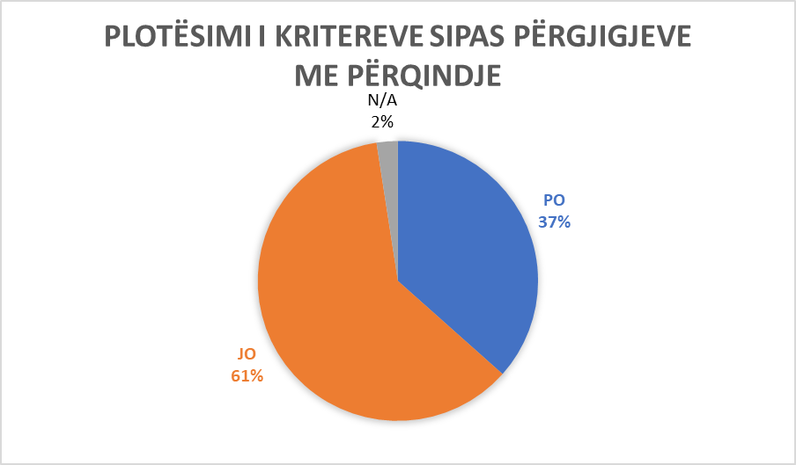

Municipality of Kllokot/ Klokot

Municipality of Mitrovica Jugore/ Južna Mitrovica –South Mitrovica
Ordinal number | The answer received from the municipality | Additional comments
Question No. 1  Are there tactile surfaces on public roads in your municipality and are they built according to Article 8 of Administrative Instruction No. 33/2007 for Construction Buildings Technical Terms of Accessibility to Disabled Persons (hereinafter: AI)? | NO
Question No.2  Are the ramps in public spaces and roads built according to Article 10 of the AI? | NO
Question No. 3  Are the stairs in the municipal public spaces built according to Article 11 of the AI? | NO
Question No. 4  Do the elevators in municipal public institutions fulfill the conditions according to Article 12 of the AI? | NO
Question No. 5  Do you have vertical lifting platforms and inclined folding lifting platforms in public institutions and do they meet the conditions according to Articles 13 and 14 of the AI? | NO
Question No. 6  Do the entrances to municipal public institutions meet the conditions according to Article 16 of the AI? | YES | Yes, it complements, in the building of the Municipal Assembly, the building where the Directorate of Culture, MFMC, Employment Agency, Social is located.
Question No. 7  Do communication (communication spaces) meet conditions according to Article 17 of AI in municipal public spaces ? | NO
Question No. 8  Do WC spaces in public municipal facilities meet conditions according to Article 18 of the AI? | NO
Question No. 9  Do the bathrooms meet conditions according to Article 19 of the AI in public municipal spaces? | NO
Question No. 10  Do kitchens meet conditions according to Article 20 of the AI in municipal public spaces,? | NO
Question No. 11  Do classrooms and work spaces in public municipal facilities meet conditions according to Article 21 of the AI? | NO | They partially fulfill the conditions, in the municipality building and in the hospital.
Question No. 12  Do Collective housing in the territory of the municipality meet the criteria according to Article 22 of the AI? | NO
Question No. 13  Do cafes and restaurants in the territory of the municipality meet the criteria according to Article 23 of the AI? | NO
Question No. 14  Do fitting rooms in business facilities in the territory of the municipality meet the criteria according to Article 24 of the AI? | NO
Question No. 15  Do the shower cabins in the business facilities of the municipality's territory meet the criteria according to Article 25 of the AI? | NO
Question No. 16  Do entrances to the swimming pool in the territory of the municipality meet the criteria according to Article 26 of the AI? | NO
Question No. 17  Do the seats in the tribune places in the territory of the municipality, meet the criteria according to Article 27 of the AI? | NO
Question No. 18  Does telephone, textphone, fax and ATM in the territory of the municipality meet the criteria according to article 28 of the AI? | NO
Question No. 19  Does electrical installations in public municipal facilities meet the criteria according to article 29 of the AI? | NO
Question No. 20  Does door and windows handles in public municipal facilities meet the criteria according to Article 30 of the AI? | YES | Yes, in some of the municipal public facilities, for example: Municipal Assembly, MFMC, Regional Hospital, Museum, Educational Institutions, etc..
Question No. 21  Do service poits in public municipal facilities meet the criteria according to article 31 of the AI? | NO
Question No. 22  Does service counter in public municipal facilities meet the criteria according to Article 32 of the AI? | NO
Question No. 23  Do the inductive areas or the transmission circle in public municipal spaces meet the criteria according to Article 33 of the AI? | NO
Question No. 24  Do notice boards in municipal public spaces meet the criteria according to Article 34 of the AI? | NO
Question No. 25  Do orientation plans for movement in public municipal buildings meet the criteria according to article 35 of the AI? | NO
Question No. 26  Do bus stations and and platforms in the territory of the municipality meet the criteria according to Article 37 of the AI? | NO
Question No. 27  Do parking spaces in collective spaces in the territory of the municipality meet the criteria according to Article 38 of the AI? | NO
Question No. 28  Do public surfaces - pedestrian paths in the territory of the municipality meet the criteria according to Article 39 of the AI? | NO
Question No. 29  Do the traffic lights in the territory of the municipality meet the criteria according to Article 40 of the AI? | NO
Question No. 30  Do pedestrian crossings in the territory of the municipality meet the criteria according to Article 41 of the AI? | NO
Question No. 31  Do pedestrian islands in the territory of the municipality meet the criteria according to Article 42 of the AI? | NO
Question No. 32  Do the crossroads in the territory of the municipality meet the criteria according to Article 43 of the AI? | NO
Question No. 33  In the course of designing and implementation of projects, public buildings with work purpose, do you adhere to Article 44 of the AI? | NO
Question No. 34  Are the entrance gates to buildings accessible based on article 45 of the AI? | YES | The entrance gate to some buildings such as the Municipal Assembly, Health Center, hospital meets these conditions.
Question No. 35  Do the buildings where people with disabilities are employed meet the criteria according to Article 48 of the AI? | NO
Question No. 36  Do cafes, restaurants, etc., meet the criteria according to Article 49 of the AI? | NO
Question No. 37  Do public parking lots and public garages meet the criteria according to Article 50 of the AI? | NO
Question No. 38  During the reconstruction of buildings in your municipality, do you adhere to Article 51 of the AI? | NO
Question No. 39  Is the content of the conceptual project in your municipality based on Article 55 of the AI? | YES | Conceptual projects mainly meet the norms of approaches and adaptability in space.
Question No. 40  Is the content of the main project in your municipality based on article 56 of the AI? | NO | Partially
Question No. 41  Is the content of the implementation project in your municipality based on Article 57 of the AI? | NO | Partially
Additional Comments:

(In this space you can add any other information related to the questionnaire in general)

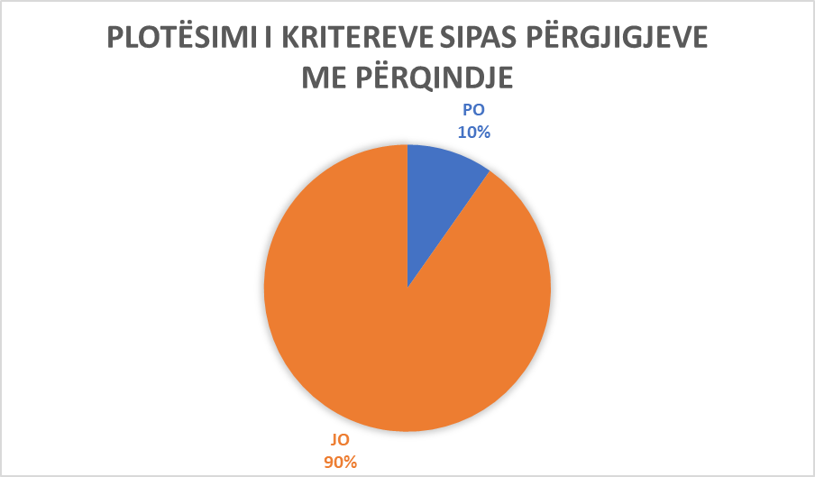
Municipality of Mitrovica Jugore/ Južna Mitrovica –South Mitrovica

Municipality of Graçanic/ Gračanica
Ordinal number | The answer received from the municipality | Additional comments
Question No. 1  Are there tactile surfaces on public roads in your municipality and are they built according to Article 8 of Administrative Instruction No. 33/2007 for Construction Buildings Technical Terms of Accessibility to Disabled Persons (hereinafter: AI)? | NO
Question No.2  Are the ramps in public spaces and roads built according to Article 10 of the AI? | NO | Public municipal buildings have ramps, but they are not built according to all the guidelines from AI.
Question No. 3  Are the stairs in the municipal public spaces built according to Article 11 of the AI? | NO
Question No. 4  Do the elevators in municipal public institutions fulfill the conditions according to Article 12 of the AI? | NO | The only elevator in the Municipal Public Institutions is the Municipality building, but it is currently not in operation.
Question No. 5  Do you have vertical lifting platforms and inclined folding lifting platforms in public institutions and do they meet the conditions according to Articles 13 and 14 of the AI? | JO
Question No. 6  Do the entrances to municipal public institutions meet the conditions according to Article 16 of the AI? | YES | All public facilities of municipal institutions generally meet the requirements of Article 16 of the AI.
Question No. 7  Do communication (communication spaces) meet conditions according to Article 17 of AI in municipal public spaces ? | YES | (no comment)
Question No. 8  Do WC spaces in public municipal facilities meet conditions according to Article 18 of the AI? | NO
Question No. 9  Do the bathrooms meet conditions according to Article 19 of the AI in public municipal spaces? | NO
Question No. 10  Do kitchens meet conditions according to Article 20 of the AI in municipal public spaces,? | NO
Question No. 11  Do classrooms and work spaces in public municipal facilities meet conditions according to Article 21 of the AI? | NO | Student classrooms and buildings meet most, but not all, of the requirements of this Article.
Question No. 12  Do collective housing in the territory of the municipality meet the criteria according to Article 22 of the AI? | NO | The municipality of Graçanica carries out construction projects according to standards, while users equip the space according to their needs.
Question No. 13  Do cafes and restaurants in the territory of the municipality meet the criteria according to Article 23 of the AI? | NO | Cafes and restaurants meet certain conditions of Article 23 of the AI.
Question No. 14  Do fitting rooms in business facilities in the territory of the municipality meet the criteria according to Article 24 of the AI? | NO
Question No. 15  Do the shower cabins in the business facilities of the municipality's territory meet the criteria according to Article 25 of the AI? | NO | Not because we don't have information.
Question No. 16  Do entrances to the swimming pool in the territory of the municipality meet the criteria according to Article 26 of the AI? | NO | No information available.
Question No. 17  Do the seats in the tribune places in the territory of the municipality, meet the criteria according to Article 27 of the AI? | YES | Houses of culture meet the requirements, but do not have a sign.
Question No. 18  Does telephone, textphone, fax and ATM in the territory of the municipality meet the criteria according to article 28 of the AI? | NO
Question No. 19  Does electrical installations in public municipal facilities meet the criteria according to article 29 of the AI? | YES | Electrical installations in all municipal public facilities generally meet the requirements of Article 29 of the AI.
Question No. 20  Does door and windows handles in public municipal facilities meet the criteria according to Article 30 of the AI? | NO
Question No. 21  Do service poits in public municipal facilities meet the criteria according to article 31 of the AI? | NO
Question No. 22  Does service counter in public municipal facilities meet the criteria according to Article 32 of the AI? | NO
Question No. 23  Do the inductive areas or the transmission circle in public municipal spaces meet the criteria according to Article 33 of the AI? | NO
Question No. 24  Do notice boards in municipal public spaces meet the criteria according to Article 34 of the AI? | YES | (no comments)
Question No. 25  Do orientation plans for movement in public municipal buildings meet the criteria according to article 35 of the AI? | NO
Question No. 26  Do bus stations and and platforms in the territory of the municipality meet the criteria according to Article 37 of the AI? | N/A | There are no platforms in the municipality of Graçanica. The locations mostly meet the conditions, while we have no information about the means of transport.
Question No. 27  Do parking spaces in collective spaces in the territory of the municipality meet the criteria according to Article 38 of the AI? | NO | The parking spaces do not meet all the conditions from Article 38 of the AI.
Question No. 28  Do public surfaces - pedestrian paths in the territory of the municipality meet the criteria according to Article 39 of the AI? | NO
Question No. 29  Do the traffic lights in the territory of the municipality meet the criteria according to Article 40 of the AI? | N/A | There are no traffic lights in the territory of Graçanica municipality.
Question No. 30  Do pedestrian crossings in the territory of the municipality meet the criteria according to Article 41 of the AI? | NO
Question No. 31  Do pedestrian islands in the territory of the municipality meet the criteria according to Article 42 of the AI? | N/A | There is no any.
Question No. 32  Do the crossroads in the territory of the municipality meet the criteria according to Article 43 of the AI? | NO
Question No. 33  In the course of designing and implementation of projects, public buildings with work purpose, do you adhere to Article 44 of the AI? | YES | Any responsible engineer who designs any type of facility adheres to the standard.
Question No. 34  Are the entrance gates to buildings accessible based on article 45 of the AI? | N/A | Article 45 of the AI does not clearly define the required condition.
Question No. 35  Do the buildings where people with disabilities are employed meet the criteria according to Article 48 of the AI? | NO | We are not able to fully answer this question, but we consider that the conditions are offered by the employer.
Question No. 36  Do cafes, restaurants, etc., meet the criteria according to Article 49 of the AI? | NO | Not all members are respected.
Question No. 37  Do public parking lots and public garages meet the criteria according to Article 50 of the AI? | N/A | There are no public garages in the territory of the municipality of Graçanica, the parking spaces meet the requirements, but not all places are marked.
Question No. 38  During the reconstruction of buildings in your municipality, do you adhere to Article 51 of the AI? | NO | We do not adhere to all that is defined by article 51 of the AI.
Question No. 39  Is the content of the conceptual project in your municipality based on Article 55 of the AI? | YES | Each conceptual project must contain technical details which are required by the municipal authority and the investor is obliged to provide them.
Question No. 40  Is the content of the main project in your municipality based on article 56 of the AI? | YES | The content of the main project meets the requirements of Article 56 of the AI.
Question No. 41  Is the content of the implementation project in your municipality based on Article 57 of the AI? | N/A | Article 57 AI is unclear.
Additional Comments:  (In this space you can add any other information related to the questionnaire in general) |  | “For a large number of business facilities in the territory of the municipality of Graçanica, it can be said that they were built before the formation of the municipality, for which the municipality does not have detailed information.  The articles of the AI on the basis of which this questionnaire is referred to, are unclear and inadequately translated”.

Municipality of Graçanicë/ Gračanica

Municpality of Drenas/ Glogovc
Ordinal number | The answer received from the municipality | Additional comments
Question No. 1  Are there tactile surfaces on public roads in your municipality and are they built according to Article 8 of Administrative Instruction No. 33/2007 for Construction Buildings Technical Terms of Accessibility to Disabled Persons (hereinafter: AI)? | NO
Question No.2  Are the ramps in public spaces and roads built according to Article 10 of the AI? | YES
Question No. 3  Are the stairs in the municipal public spaces built according to Article 11 of the AI? | YES | In the facility of the Municipality, in the health institutions.
Question No. 4  Do the elevators in municipal public institutions fulfill the conditions according to Article 12 of the AI? | YES | Elevator inside the municipality building.
Question No. 5  Do you have vertical lifting platforms and inclined folding lifting platforms in public institutions and do they meet the conditions according to Articles 13 and 14 of the AI? | YES | All primary health care institutions are equipped with ramps according to Article AI 13, 14.
Question No. 6  Do the entrances to municipal public institutions meet the conditions according to Article 16 of the AI? | YES | The entrance space in the municipality facility meets the conditions.
Question No. 7  Do communication (communication spaces) meet conditions according to Article 17 of AI in municipal public spaces ? | YES | In the facility of the municipality, it fulfills the conditions.
Question No. 8  Do WC spaces in public municipal facilities meet conditions according to Article 18 of the AI? | YES | In the facility of the municipality, it fulfills the conditions.
Question No. 9  Do the bathrooms meet conditions according to Article 19 of the AI in public municipal spaces? | YES | In the facility of the Municipality, it fulfills the conditions.
Question No. 10  Do kitchens meet conditions according to Article 20 of the AI in municipal public spaces,? | NO
Question No. 11  Do classrooms and work spaces in public municipal facilities meet conditions according to Article 21 of the AI? | YES | It meets conditions in the facility of the Municipality.
Question No. 12  Do Collective housing in the territory of the municipality meet the criteria according to Article 22 of the AI? | YES | The new collective facilities meet the criteria, while the old collective facilities partially meet them. All collective facilities are located within the urban area.
Question No. 13  Do cafes and restaurants in the territory of the municipality meet the criteria according to Article 23 of the AI? | YES | They meet the criteria. They are located in the territory of Drenas municipality.
Question No. 14  Do fitting rooms in business facilities in the territory of the municipality meet the criteria according to Article 24 of the AI? | NO | Yes, partially, and the business facilities which are located in the territory of the municipality.
Question No. 15  Do the shower cabins in the business facilities of the municipality's territory meet the criteria according to Article 25 of the AI? | NO | Partially in some business facilities.
Question No. 16  Do entrances to the swimming pool in the territory of the municipality meet the criteria according to Article 26 of the AI? | NO
Question No. 17  Do the seats in the tribune places in the territory of the municipality, meet the criteria according to Article 27 of the AI? | YES | In the city stadium.
Question No. 18  Does telephone, textphone, fax and ATM in the territory of the municipality meet the criteria according to article 28 of the AI? | YES | In the facility of the Municipality, it fulfills the conditions.
Question No. 19  Does electrical installations in public municipal facilities meet the criteria according to article 29 of the AI? | YES | In new public facilities.
Question No. 20  Does door and windows handles in public municipal facilities meet the criteria according to Article 30 of the AI? | NO | Partially.
Question No. 21  Do service poits in public municipal facilities meet the criteria according to article 31 of the AI? | NO | Partly in public municipal facilities.
Question No. 22  Does service counter in public municipal facilities meet the criteria according to Article 32 of the AI? | NO
Question No. 23  Do the inductive areas or the transmission circle in public municipal spaces meet the criteria according to Article 33 of the AI? | NO
Question No. 24  Do notice boards in municipal public spaces meet the criteria according to Article 34 of the AI? | YES | (no comment)
Question No. 25  Do orientation plans for movement in public municipal buildings meet the criteria according to article 35 of the AI? | NO
Question No. 26  Do bus stations and and platforms in the territory of the municipality meet the criteria according to Article 37 of the AI? | YES | We have locations in 19 stops: Verboc (1), Shtuticë (1), Tertstenik (1), Baicë (2), Terdec (1), Llapushik (1), Nekoc (2), Fushtice e Ultë (1), Kizhareke (1), Sankoc (1), Gradicë (1), Likoshan (1), Qikatove Vjeter (1), Gllanselle (1), Dobreshece (1), Abri (1), Krojkovë (1).
Question No. 27  Do parking spaces in collective spaces in the territory of the municipality meet the criteria according to Article 38 of the AI? | YES | There are 17 parking lots with a total of 2008 parking spaces.
Question No. 28  Do public surfaces - pedestrian paths in the territory of the municipality meet the criteria according to Article 39 of the AI? | YES | Yes, they meet the criteria.
Question No. 29  Do the traffic lights in the territory of the municipality meet the criteria according to Article 40 of the AI? | N/A | There are no traffic lights.
Question No. 30  Do pedestrian crossings in the territory of the municipality meet the criteria according to Article 41 of the AI? | YES | All local roads in the city center and in all villages meet the required criteria.
Question No. 31  Do pedestrian islands in the territory of the municipality meet the criteria according to Article 42 of the AI? | YES | They meet the criteria, and are in the city center and in some villages.
Question No. 32  Do the crossroads in the territory of the municipality meet the criteria according to Article 43 of the AI? | YES | Yes, all local road intersections in all villages are equipped with a vertical 'STOP' traffic sign.
Question No. 33  In the course of designing and implementation of projects, public buildings with work purpose, do you adhere to Article 44 of the AI? | YES | In public facilities.
Question No. 34  Are the entrance gates to buildings accessible based on article 45 of the AI? | YES | (no comments )
Question No. 35  Do the buildings where people with disabilities are employed meet the criteria according to Article 48 of the AI? | YES | (no comments )
Question No. 36  Do cafes, restaurants, etc., meet the criteria according to Article 49 of the AI? | YES | In the territory of the municipality, city.
Question No. 37  Do public parking lots and public garages meet the criteria according to Article 50 of the AI? | YES | They meet the criteria in all parking lots in the city and at schools, that is, 17 parking lots in the city and 34 parking lots in schools and kindergartens.
Question No. 38  During the reconstruction of buildings in your municipality, do you adhere to Article 51 of the AI? | YES | Public construction facilities.
Question No. 39  Is the content of the conceptual project in your municipality based on Article 55 of the AI? | YES | For designed projects (conceptual).
Question No. 40  Is the content of the main project in your municipality based on article 56 of the AI? | YES | For designed projects (conceptual).
Question No. 41  Is the content of the implementation project in your municipality based on Article 57 of the AI? | YES | For designed projects (conceptual).
Additional Comments:  (In this space you can add any other information related to the questionnaire in general) |  | No comments.

Municpality of Drenas/ Glogovc

The percentage of implementation of the instruction criteria by 21 municipalities of the Republic of Kosovo
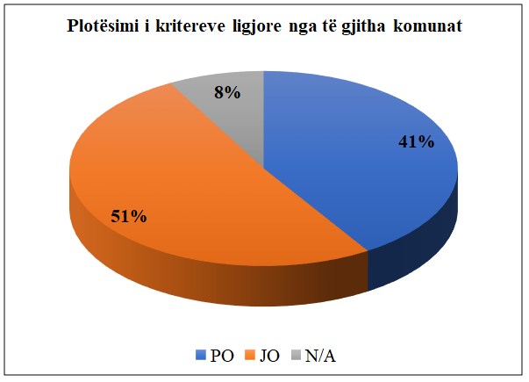

MFMC – Main Family Medicine Center
CSW – Qendra për Punë Sociale
PTK – Post and Telecommunication of Kosovo

